

Dayanand Education Society’s

Dayanand Science College, Latur

**UGC-CPE, DST-FIST, NAAC Re-accredited “A+” Grade College**

Affiliated to

**Swami Ramanand Teerth Marathwada University,Nanded**

## A

## Project Report on

**ROBOCART**

Submitted for the award of degree of

# Bachelor of Computer Science

### By:

SURYAWANSHI SHUBHAM ANIL : ZC30457

THAKUR SUMEET HEMANT : ZC30463

WAGHMARE SNEHA VIRENDRA : ZC30466

**In Year: 2024 – 2025**



## Dayanand Education Society’s DAYANAND SCIENCE LATUR.

**CERTIFICATE**

This is to certify that the project entitled **“ROBOCART”** has been carried out by **Suryawanshi Shubham Anil, Thakur Sumeet Hemant, Waghmare Sneha Virendra** under my guidance in partial fulfillment of the degree i.e. Bachelor of Computer Science of SRTMU, Nanded during the academic year 2024-2025.

|  |  |  |
| --- | --- | --- |
| **Mr. V. G. Kulkarni** | **Dr. S. A. Jaju** | **Dr. R. B. Shinde** |
| Guide | Coordinator | HOD |
|  |  |  |
| **Internal Examiner** |  | **External Examiner** |
|  |  |  |



# ACKNOWLEDGEMENT

We would like to convey our gratitude to **Dr. S. S. Bellale**, Principal of **Dayanand Science College, Latur** who always promote us for Research and development project.

We are grateful to **Swami Ramanand Teerth Marathwada University, Nanded** for giving an opportunity to deliver project.

We would like to thank Project Guide **Mr. V. G. Kulkarni** who guided us through doing these project development process, provided with invaluable advice, helped us in difficult periods and provided practical assistant for our project. Their willingness to motivate us contributed tremendously to the success of this project.

We would like to express our special thanks of gratitude to our Head of Department **Dr. R. B. Shinde** and Co-Ordinator of the Department of Computer Science **Dr. S. A. Jaju** who helped us a lot in finalizing this project.

Besides we would like to thank all staff members who helped us by giving advice and providing equipment which we needed.

Last but not in least we would like to thank all who helped and motivated us.

### With Sincere Thanks, Suryawanshi Shubham Anil Thakur Sumeet Hemant Waghmare Sneha Virendra

Index

|  |  |  |
| --- | --- | --- |
| **Sr. No.** | **Topic Name** | **Page No.** |
| **1** | **Abstract** | 5 |
| **2** | **Introduction:** | 6 |
|  | 2.1 Project Overview |  |
|  | 2.2 Project Plan (Gantt chart) |  |
| **3** | **Project Requirement:** | 8 |
|  | 3.1 Hardware Requirement |  |
|  | 3.2 Software Requirement |  |
|  | 3.3 Field Work |  |
|  | 3.4 Front End |  |
|  | 3.5 Back End |  |
| **4** | **System Design:** | 10 |
|  | 4.1 Database Design |  |
|  | 4.2 E-R Diagram |  |
|  | 4.3 Data Flow Diagram |  |
| **5** | **Designing:** | 15 |
| **6** | **Coding:** | 19 |
|  | **Report** |  |
| **7** | **Conclusion** | 76 |
| **8** | **Future scope of project:** | 78 |
| **9** | **Bibliography:** | 79 |
|  | 9.1 Book(s) |  |
|  | 9.2 Website(s) |  |

# Abstract

Robocart is an online platform designed to streamline the purchase and carting of robotics-related components. The project aims to provide a user-friendly interface for hobbyists, students, and professionals to easily browse, select, and purchase essential electronic and mechanical parts.

By integrating an efficient product catalog, secure payment options, and seamless cart management, Robocart enhances the shopping experience for robotics enthusiasts. The platform may also incorporate features like product recommendations, real-time stock updates, and order tracking.

Robocart's goal is to become a go-to marketplace for high-quality robotics components, ensuring convenience and accessibility for innovators and makers.

# Introduction

* **Purpose of project -**

Robocart is an online platform designed to simplify the process of purchasing robotics-related components. The primary goal is to provide students, hobbyists, and professionals with fficiently browse, select, and order essential electronic and mechanical parts.

The platform ensures a seamless shopping experience by integrating an intuitive interface, secure transactions, and real-time stock a one-stop marketplace where they can e

management.

* **Objective of System -**

The key objectives of the Robocart system are:

* To develop an e-commerce platform specifically for robotics components.
* To enable users to easily search, filter, and purchase required parts.
* To implement a secure and efficient cart and checkout system.
* To provide real-time inventory updates and order tracking.
* To enhance user experience through recommendations and categorized product listings.
* **User Registration and Authentication:**

To ensure secure access, Robocart includes a user registration and authentication system. New users must sign up with valid credentials, including email verification. The platform implements authentication mechanisms such as:

* **Login/Signup:**

Users must create an account before accessing full platform features.

* **Secure Authentication:**

Password hashing and encrypted login credentials ensure data security.

* **User Roles:**

The system differentiates between customers (buyers) and administrators (managing inventory and orders).

* **Session Management:**

Ensures users remain logged in while maintaining security against unauthorized access.

* 1. **Project Plan (Gantt chart)**

|  |  |  |  |  |  |  |
| --- | --- | --- | --- | --- | --- | --- |
| **Sr.no** | **Task Name** | **20-Dec** | **25-Dec** | **10-Jan** | **25-Jan** | **02-Mar** |
| **1** | Requirement Gathering |  |  |  |  |  |
| **2** | Planning |  |  |  |  |  |
| **3** | Designing |  |  |  |  |  |
| **4** | Coding |  |  |  |  |  |
| **5** | Testing and Deployment |  |  |  |  |  |

# Project Requirement

## Hardware Requirement

**Processor :** Intel i3/ AMD Ryzen3 or Higher.

**Ram :** 4 GB or Higher.

**Hard Disk :** 50 GB or Higher.

**Monitor :** LCD Display

## Software Requirement

**Browser :** Any modern Browser after I.E.5.0. (Google Chrome).

**IDE :** Visual Studio Code (VS Code) & Android Studio.

**Backend :** Php

**Web Server :** XAMPP Server

**Database :** MySql

## Field work

The Robocart website has been through any type of invigorating finish and validation the possibilities in real world can cause to make sure of its functionality, performance, and security. I will start by testing out a variety of use cases, committing to identifying and fixing any bugs that crop up, and gauging user satisfaction all in an effort to improve overall engagement.

## Front end

HTML,CSS,JAVASCRIPT.

## Back end

Php,Sql, etc.

# System Design

A well-designed system architecture is written in Robocart Website for effective data and the smooth user interaction. The Data Management Plan is composed of two major thins, which are data organization within the database and the setting of the relationship between entities to be clear and logic.

## Database

The database design of the Online Grocery Shopping app revolves around several key entities. Each entity has specific attributes and relationships, as outlined below:

### Userpass Table:



* Attributes:

o mem_id (Primary Key)

o username

o password

### USER Table:

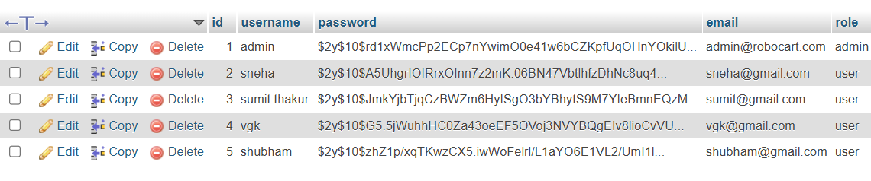

* Attributes:
  + ID
  + USERNAME
  + PASSWORD
  + EMAIL
  + ROLE

### Project Details:

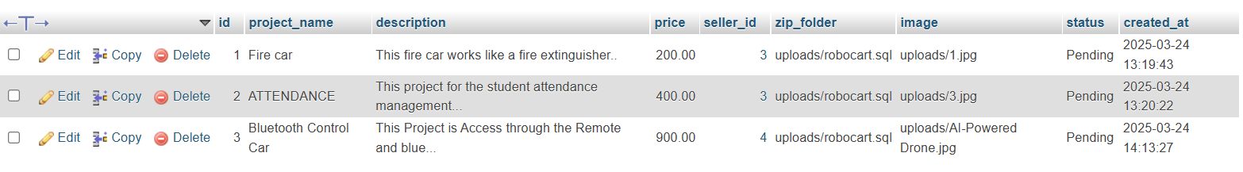

* Attributes:
  + ID
  + PROJECT_NAME
  + DESCRIPTION
  + PRICE
  + SELLER_ID
  + ZIP_FOLDER
  + IMAGES
  + STATUS
  + CREATED_AT
  1. **ER Diagram**

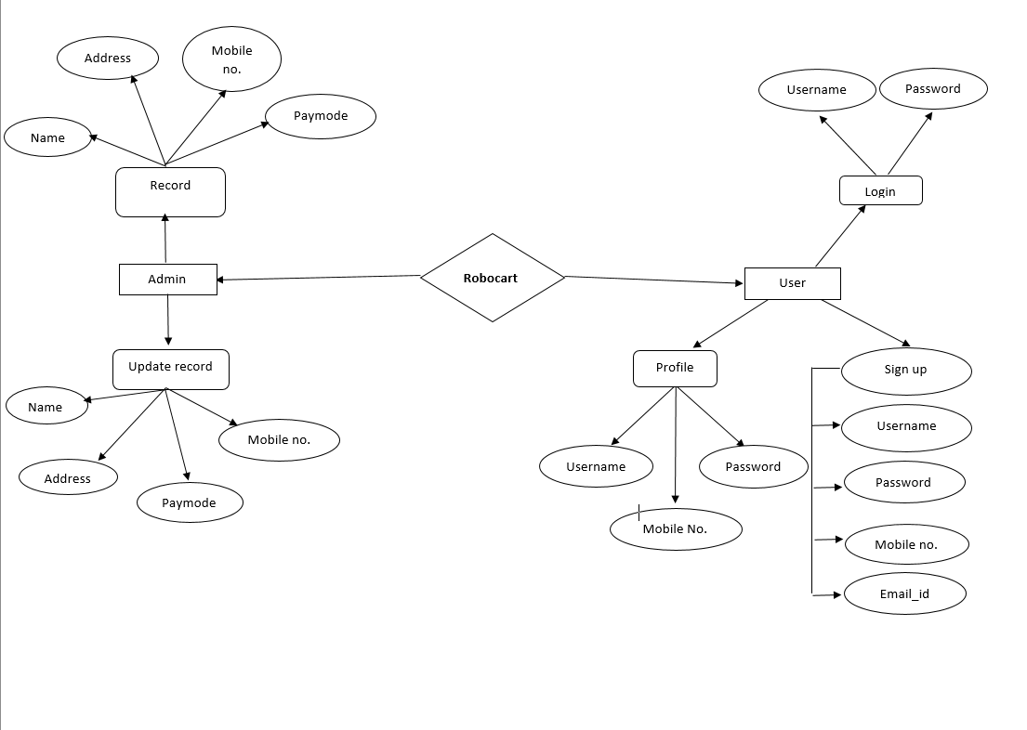

* 1. **Data Flow Diagram**

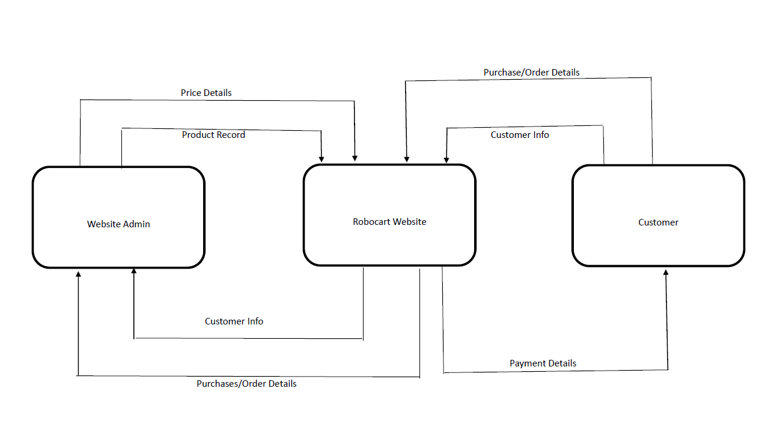

# Designing

Designing an Robocart built on the involves creating a user-friendly and visually appealing interface to facilitate smooth navigation and efficient use of features.

Here's a guide to designing the user interface (UI) for your project:

Key aspects of the design include:

* **User Interface (UI):** Having the capability of making informative screens for will be such an effective tool.

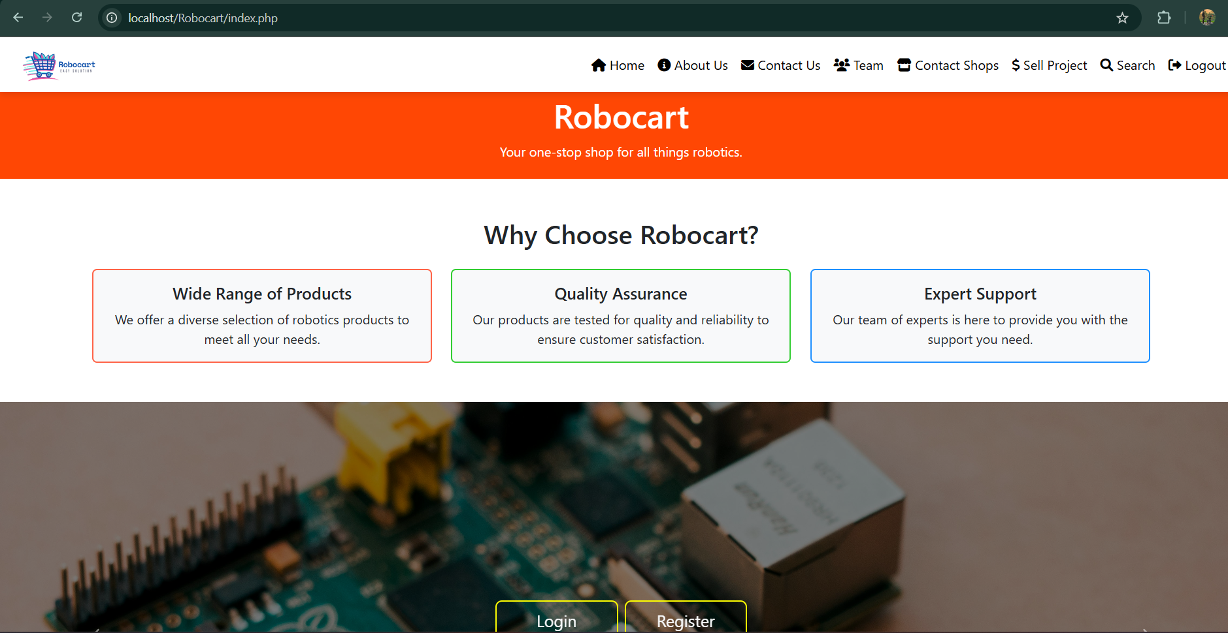

* + **Product arrangement in Homepage:**

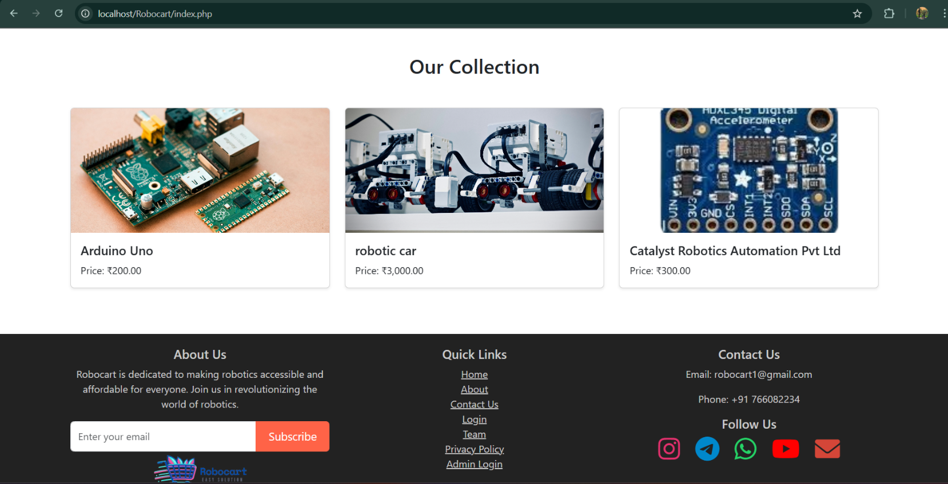

### Register Page:

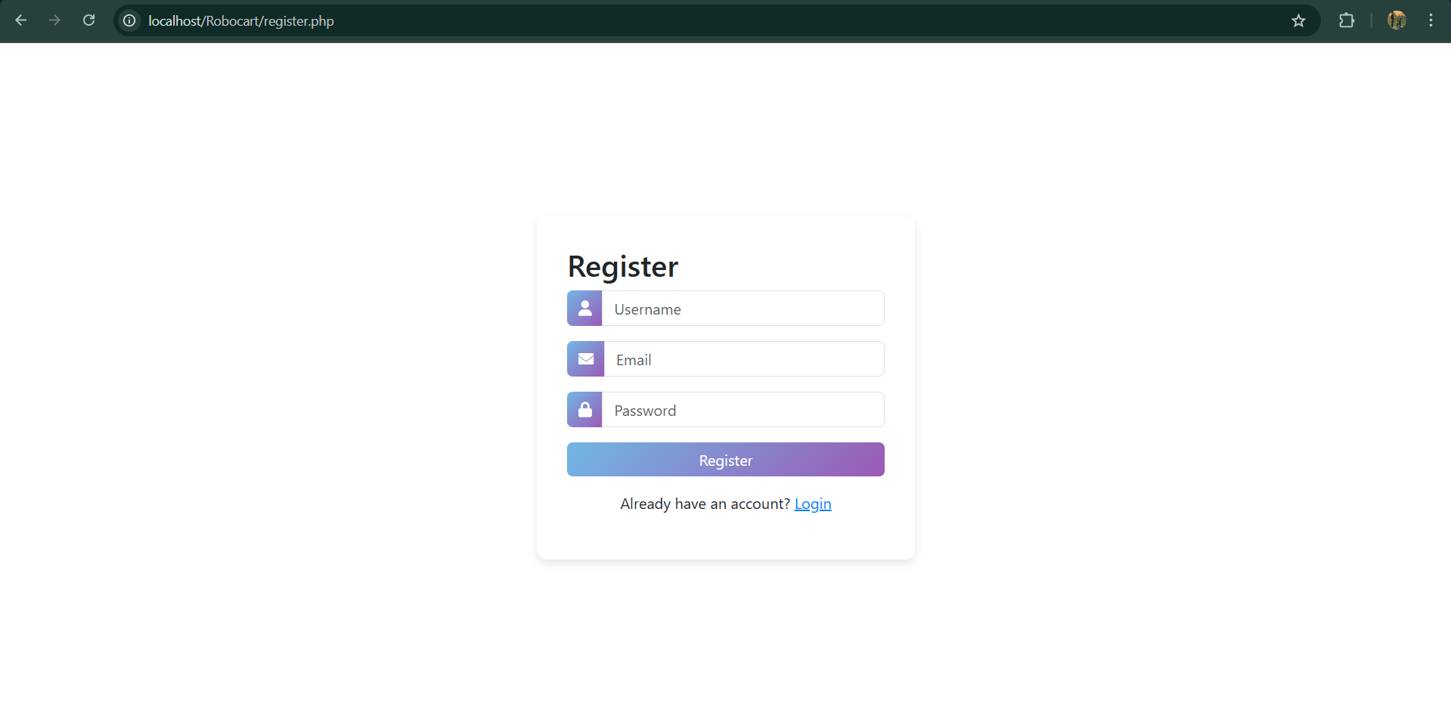

* + Design a form where users can enter their registration details such as username, Email, password, etc.
  + Include input fields for each required piece of information and labels to indicate the purpose of each field.

### Login Page:

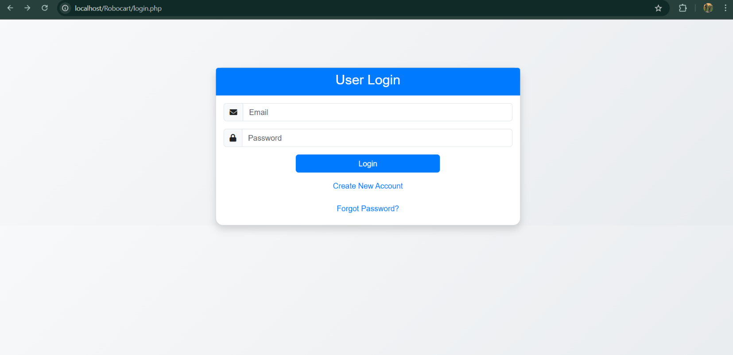

# Coding:

# Report

* **User Authentication:** Integrating user registration, login, password management to guarantee protecting the application credentials.

### Register page:

<?php

include 'config.php'; // Include database connection

session_start();

if ($_SERVER['REQUEST_METHOD'] == 'POST' && isset($_POST['register'])) {

if (isset($_POST['username']) && isset($_POST['email']) && isset($_POST['password'])) {

$username = $_POST['username'];

$email = $_POST['email'];

$password = password_hash($_POST['password'], PASSWORD_BCRYPT);

$sql = "INSERT INTO users (username, email, password, role) VALUES (:username, :email, :password, 'user')";

$query = $conn->prepare($sql);

$query->bindParam(':username', $username, PDO::PARAM_STR);

$query->bindParam(':email', $email, PDO::PARAM_STR);

$query->bindParam(':password', $password, PDO::PARAM_STR);

$query->execute();

header('Location: login.php');

exit();

} else {

$error = "Please fill in all fields.";

}

}

?>

<!DOCTYPE html>

<html lang="en">

<head>

<meta charset="UTF-8">

<meta name="viewport" content="width=device-width, initial-scale=1.0">

<title>Register - Robocart</title>

<link href="https://cdn.jsdelivr.net/npm/bootstrap@5.3.0-alpha3/dist/css/bootstrap.min.css" rel="stylesheet">

<link rel="stylesheet" href="https://cdnjs.cloudflare.com/ajax/libs/font-awesome/6.0.0-beta3/css/all.min.css">

<style>

body {

display: flex;

justify-content: center;

align-items: center;

height: 100vh;

background: linear-gradient(135deg,rgb(255, 255, 255),rgb(255, 255, 255));

animation: backgroundAnimation 10s infinite alternate;

}

@keyframes backgroundAnimation {

0% { background: linear-gradient(135deg,rgb(255, 255, 255),rgb(255, 255, 255)); }

100% { background: linear-gradient(135deg,rgb(255, 255, 255),rgb(255, 255, 255)); }

}

.container {

background: white;

padding: 2rem;

border-radius: 10px;

box-shadow: 0 4px 8px rgba(0, 0, 0, 0.1);

animation: fadeIn 1s ease-in-out;

width: 400px;

}

@keyframes fadeIn {

from { opacity: 0; transform: translateY(-20px); }

to { opacity: 1; transform: translateY(0); }

}

.form-control {

transition: all 0.3s ease;

}

.form-control:focus {

box-shadow: 0 0 10px rgba(0, 123, 255, 0.5);

border-color: #007bff;

}

.btn-primary {

background: linear-gradient(135deg, #71b7e6, #9b59b6);

border: none;

transition: background 0.3s ease;

}

.btn-primary:hover {

background: linear-gradient(135deg, #9b59b6, #71b7e6);

}

.input-group-text {

background: linear-gradient(135deg, #71b7e6, #9b59b6);

border: none;

color: white;

}

</style>

</head>

<body>

<div class="container">

<h2>Register</h2>

<?php if (isset($error)): ?>

<div class="alert alert-danger" role="alert">

<?= $error ?>

</div>

<?php endif; ?>

<form method="POST" action="">

<div class="mb-3 input-group">

<span class="input-group-text"><i class="fas fa-user"></i></span>

<input type="text" class="form-control" id="username" name="username" placeholder="Username" required>

</div>

<div class="mb-3 input-group">

<span class="input-group-text"><i class="fas fa-envelope"></i></span>

<input type="email" class="form-control" id="email" name="email" placeholder="Email" required>

</div>

<div class="mb-3 input-group">

<span class="input-group-text"><i class="fas fa-lock"></i></span>

<input type="password" class="form-control" id="password" name="password" placeholder="Password" required>

</div>

<button type="submit" name="register" class="btn btn-primary w-100">Register</button>

<p class="mt-3 text-center">Already have an account? <a href="login.php" style="color: #007bff;">Login</a></p>

</form>

</div>

</body>

</html>

### Final Project File

### <?php

### session_start();

### $admin_username = 'admin';

### $admin_password = 'Robocart@123'; // You can use a hashed password for better security

### if (isset($_POST['login'])) {

### $username = $_POST['username'];

### $password = $_POST['password'];

### if ($username === $admin_username && $password === $admin_password) {

### $_SESSION['admin_id'] = 1; // You can use a specific ID for the admin

### header('Location: admin_dashboard.php');

### exit();

### } else {

### $error = "Invalid username or password.";

### }

### }

### ?>

### <!DOCTYPE html>

### <html lang="en">

### <head>

### <meta charset="UTF-8">

### <meta name="viewport" content="width=device-width, initial-scale=1.0">

### <title>Admin Login - Robocart</title>

### <link href="https://cdn.jsdelivr.net/npm/bootstrap@5.3.0-alpha3/dist/css/bootstrap.min.css" rel="stylesheet">

### <link href="https://cdnjs.cloudflare.com/ajax/libs/font-awesome/6.0.0-beta3/css/all.min.css" rel="stylesheet">

### <link href="https://cdnjs.cloudflare.com/ajax/libs/animate.css/4.1.1/animate.min.css" rel="stylesheet">

### <style>

### body {

### background: linear-gradient(135deg, #f8f9fa, #e9ecef);

### font-family: Arial, sans-serif;

### }

### .login-container {

### margin-top: 100px;

### }

### .card {

### border-radius: 15px;

### box-shadow: 0 4px 8px rgba(0, 0, 0, 0.1);

### }

### .card-header {

### background-color: #007bff;

### color: #fff;

### border-bottom: none;

### border-top-left-radius: 15px;

### border-top-right-radius: 15px;

### }

### .input-group-text {

### background-color: #f8f9fa;

### }

### .btn-primary {

### background-color: #007bff;

### border-color: #007bff;

### }

### .btn-primary:hover {

### background-color: #0056b3;

### border-color: #004085;

### }

### .btn-link {

### color: #007bff;

### text-decoration: none;

### }

### .btn-link:hover {

### color: #0056b3;

### text-decoration: underline;

### }

### .animate__animated {

### animation-duration: 1s;

### animation-fill-mode: both;

### }

### .animate__pulse {

### animation-name: pulse;

### }

### @keyframes pulse {

### 0% {

### transform: scale(1);

### }

### 50% {

### transform: scale(1.05);

### }

### 100% {

### transform: scale(1);

### }

### }

### </style>

### </head>

### <body>

### <div class="container login-container">

### <div class="row justify-content-center">

### <div class="col-md-6">

### <div class="card shadow animate__animated animate__fadeIn">

### <div class="card-header text-center">

### <h3>Admin Login</h3>

### </div>

### <div class="card-body">

### <?php if (isset($error)): ?>

### <div class="alert alert-danger animate__animated animate__shakeX" role="alert">

### <?= $error ?>

### </div>

### <?php endif; ?>

### <form method="POST" action="">

### <div class="mb-3 input-group">

### <span class="input-group-text"><i class="fas fa-user"></i></span>

### <input type="text" class="form-control" id="username" name="username" placeholder="Username" required>

### </div>

### <div class="mb-3 input-group">

### <span class="input-group-text"><i class="fas fa-lock"></i></span>

### <input type="password" class="form-control" id="password" name="password" placeholder="Password" required>

### </div>

### <div class="d-flex justify-content-center">

### <button type="submit" name="login" class="btn btn-primary w-50 animate__animated animate__pulse">Login</button>

### </div>

### </form>

### </div>

### </div>

### </div>

### </div>

### </div>

### <!-- Bootstrap JS -->

### <script src="https://cdn.jsdelivr.net/npm/bootstrap@5.3.0-alpha3/dist/js/bootstrap.bundle.min.js"></script>

### </body>

### </html>

**Login page:**

<?php

session_start(); // ADD THIS LINE!

include 'config.php'; // Include database connection

if ($_SERVER['REQUEST_METHOD'] == 'POST' && isset($_POST['login'])) {

    if (isset($_POST['email']) && isset($_POST['password'])) {

        $email = $_POST['email'];

        $password = $_POST['password'];

        $sql = "SELECT * FROM users WHERE email = :email AND role = 'user'";

        $query = $conn->prepare($sql);

        $query->bindParam(':email', $email, PDO::PARAM_STR);

        $query->execute();

        $result = $query->fetch(PDO::FETCH_ASSOC);

         // If email and password match

        if ($result && password_verify($password, $result['password'])) {

            $_SESSION['user_id'] = $result['id'];

            // Set session variables right here!

            $_SESSION['login_user'] = $result['username']; // Storing the username

            $_SESSION['login_post'] = $result['role'];     // Storing the role

            // Redirect to index.php after successful login

            header('Location: index.php');

            exit();

        } else {

            $error = "Invalid email or password.";

        }

    } else {

        $error = "Please fill in both email and password.";

    }

}

?>

<!DOCTYPE html>

<html lang="en">

<head>

    <meta charset="UTF-8">

    <meta name="viewport" content="width=device-width, initial-scale=1.0">

    <title>User Login - Robocart</title>

    <link href="https://cdn.jsdelivr.net/npm/bootstrap@5.3.0-alpha3/dist/css/bootstrap.min.css" rel="stylesheet">

    <link href="https://cdnjs.cloudflare.com/ajax/libs/font-awesome/6.0.0-beta3/css/all.min.css" rel="stylesheet">

    <style>

        body {

            background: linear-gradient(135deg, #f8f9fa, #e9ecef);

            font-family: Arial, sans-serif;

        }

        .login-container {

            margin-top: 100px;

        }

        .card {

            border-radius: 15px;

            box-shadow: 0 4px 8px rgba(0, 0, 0, 0.1);

        }

        .input-group-text {

            background-color: #f8f9fa;

        }

        .btn-primary {

            background-color: #007bff;

            border-color: #007bff;

        }

        .btn-primary:hover {

            background-color: #0056b3;

            border-color: #004085;

        }

        .btn-secondary {

            background-color: #6c757d;

            border-color: #6c757d;

        }

        .btn-secondary:hover {

            background-color: #5a6268;

            border-color: #545b62;

        }

        .btn-link {

            color: #007bff;

            text-decoration: none;

        }

        .btn-link:hover {

            color: #0056b3;

            text-decoration: underline;

        }

        .card-header {

            background-color: #007bff;

            color: #fff;

            border-bottom: none;

            border-top-left-radius: 15px;

            border-top-right-radius: 15px;

        }

        .text-link {

            color: #007bff;

            text-decoration: none;

        }

        .text-link:hover {

            color: #0056b3;

            text-decoration: underline;

        }

    </style>

</head>

<body>

    <div class="container login-container">

        <div class="row justify-content-center">

            <div class="col-md-6">

                <div class="card shadow">

                    <div class="card-header text-center">

                        <h3>User Login</h3>

                    </div>

                    <div class="card-body">

                        <?php if (isset($error)): ?>

                            <div class="alert alert-danger" role="alert">

                                <?= $error ?>

                            </div>

                        <?php endif; ?>

                        <form method="POST" action="">

                            <div class="mb-3 input-group">

                                <span class="input-group-text"><i class="fas fa-envelope"></i></span>

                                <input type="email" class="form-control" id="email" name="email" placeholder="Email" required>

                            </div>

                            <div class="mb-3 input-group">

                                <span class="input-group-text"><i class="fas fa-lock"></i></span>

                                <input type="password" class="form-control" id="password" name="password" placeholder="Password" required>

                            </div>

                            <div class="d-flex justify-content-center">

                                <button type="submit" name="login" class="btn btn-primary w-50 animate__animated animate__pulse">Login</button>

                            </div>

                        </form>

                        <div class="mt-3 text-center">

                            <a href="register.php" class="text-link">Create New Account</a>

                        </div>

                        <div class="mt-3 text-center">

                            <a href="forgot_password.php" class="btn btn-link">Forgot Password?</a>

                        </div>

                    </div>

                </div>

            </div>

        </div>

    </div>

    <!-- Bootstrap JS -->

    <script src="https://cdn.jsdelivr.net/npm/bootstrap@5.3.0-alpha3/dist/js/bootstrap.bundle.min.js"></script>

</body>

</html>

**Registration Page:**

<!-- filepath: /c:/xampp/htdocs/Robocart/includes/registration.php -->

<?php

if (session_status() == PHP_SESSION_NONE) {

    session_start();

}

error_reporting(E_ALL);

ini_set('display_errors', 1);

include('config.php'); // Include the config file with database connection details

$error = '';

$msg = '';

if ($_SERVER['REQUEST_METHOD'] == 'POST') {

    if (isset($_POST['username']) && isset($_POST['email']) && isset($_POST['password'])) {

        $username = $_POST['username'];

        $email = $_POST['email'];

        $password = password_hash($_POST['password'], PASSWORD_BCRYPT); // Hash the password

        $sql = "INSERT INTO users (username, email, password) VALUES (:username, :email, :password)";

        $query = $conn->prepare($sql);

        $query->bindParam(':username', $username, PDO::PARAM_STR);

        $query->bindParam(':email', $email, PDO::PARAM_STR);

        $query->bindParam(':password', $password, PDO::PARAM_STR);

        $query->execute();

        header('Location: login.php');

        exit();

    } else {

        $error = "Please fill in all fields.";

    }

}

?>

<!DOCTYPE HTML>

<html lang="en">

<head>

    <meta charset="UTF-8">

    <meta name="viewport" content="width=device-width, initial-scale=1.0">

    <title>Robocart - Registration</title>

    <!-- Bootstrap CSS -->

    <link rel="stylesheet" href="assets/css/bootstrap.min.css" type="text/css">

    <!-- Custom Style -->

    <link rel="stylesheet" href="assets/css/style.css" type="text/css">

    <!-- FontAwesome Font Style -->

    <link href="assets/css/font-awesome.min.css" rel="stylesheet">

</head>

<body>

<!--Header-->

<?php include('header.php');?>

<!-- /Header -->

<!--Page Header-->

<section class="page-header registration_page">

  <div class="container">

    <div class="page-header_wrap">

      <div class="page-heading">

        <h1>Registration</h1>

      </div>

      <ul class="coustom-breadcrumb">

        <li><a href="index.php">Home</a></li>

        <li>Registration</li>

      </ul>

    </div>

  </div>

  <!-- Dark Overlay-->

  <div class="dark-overlay"></div>

</section>

<!-- /Page Header-->

<!--Registration-->

<section class="registration section-padding">

  <div class="container">

    <div class="row">

      <div class="col-md-6 col-md-offset-3">

        <h3>Register</h3>

        <?php if($error){?><div class="errorWrap"><strong>ERROR</strong>:<?php echo htmlentities($error); ?> </div><?php }

        else if($msg){?><div class="succWrap"><strong>SUCCESS</strong>:<?php echo htmlentities($msg); ?> </div><?php }?>

        <div class="registration_form gray-bg">

          <form method="post">

            <div class="form-group">

              <label class="control-label">Username <span>*</span></label>

              <input type="text" name="username" class="form-control white_bg" id="username" required>

            </div>

            <div class="form-group">

              <label class="control-label">Email Address <span>*</span></label>

              <input type="email" name="email" class="form-control white_bg" id="emailaddress" required>

            </div>

            <div class="form-group">

              <label class="control-label">Password <span>*</span></label>

              <input type="password" name="password" class="form-control white_bg" id="password" required>

            </div>

            <div class="form-group">

              <button class="btn" type="submit" name="register">Register <span class="angle_arrow"><i class="fa fa-angle-right" aria-hidden="true"></i></span></button>

            </div>

          </form>

        </div>

      </div>

    </div>

  </div>

</section>

<!-- /Registration-->

<!--Footer -->

<?php include('footer.php');?>

<!-- /Footer-->

<!--Back to top-->

<div id="back-top" class="back-top"> <a href="#top"><i class="fa fa-angle-up" aria-hidden="true"></i> </a> </div>

<!--/Back to top-->

<!-- Scripts -->

<script src="assets/js/jquery.min.js"></script>

<script src="assets/js/bootstrap.min.js"></script>

<script src="assets/js/interface.js"></script>

<!--Switcher-->

<script src="assets/switcher/js/switcher.js"></script>

<!--bootstrap-slider-JS-->

<script src="assets/js/bootstrap-slider.min.js"></script>

<!--Slider-JS-->

<script src="assets/js/slick.min.js"></script>

<script src="assets/js/owl.carousel.min.js"></script>

</body>

</html>

**Index Page:**

<?php

include 'config.php'; // Include database connection

session_start(); // Also needed here!

if (!isset($_SESSION['login_user'])) {

    header("Location: login.php"); // Redirect to login if not logged in

    exit();

}

$username = $_SESSION['login_user'];

$post = $_SESSION['login_post'];

// Fetch products from the database

$sql = "SELECT * FROM products";

$query = $conn->prepare($sql);

$query->execute();

$products = $query->fetchAll(PDO::FETCH_ASSOC);

?>

<!DOCTYPE html>

<html lang="en">

<head>

    <meta charset="UTF-8">

    <meta name="viewport" content="width=device-width, initial-scale=1.0">

    <title>Robocart - Home</title>

    <!-- Bootstrap CSS -->

    <link href="https://cdn.jsdelivr.net/npm/bootstrap@5.3.0-alpha3/dist/css/bootstrap.min.css" rel="stylesheet">

    <style>

        body {

            margin: 0;

            font-family: Arial, sans-serif;

            background: linear-gradient(135deg,rgb(255, 255, 255),rgb(255, 255, 255));

            color: #fff;

        }

        .header {

            text-align: center;

            padding: 5px;

            background: rgb(255, 71, 4);

            color: #fff;

        }

        .motive-section {

            padding: 30px 15px;

            background: rgba(235, 235, 246, 0.6);

            border-radius: 20px;

            margin: 30px 0;

            text-align: center;

        }

        .motive-section h2 {

            margin-bottom: 20px;

        }

        .carousel-item img {

            height: 80vh;

            object-fit: cover;

        }

        .content-section {

            margin: 50px auto;

            text-align: center;

        }

        .content-section h2 {

            color: #ff6347;

        }

        .product-grid-section {

            margin-bottom: 50px; /* Add margin to separate from footer */

        }

        .footer {

            background: #222;

            padding: 20px;

            color: #ccc;

            text-align: center;

        }

        .card {

            height: 100%;

            display: flex;

            flex-direction: column;

        }

        .card-body {

            flex: 1;

            display: flex;

            flex-direction: column;

        }

        .card-img-top {

            height: 200px;

            object-fit: cover;

        }

        @keyframes rise {

            from {

                transform: translateY(100vh);

                opacity: 1;

            }

            to {

                transform: translateY(-10vh);

                opacity: 0;

            }

        }

    </style>

</head>

<body>

    <!-- Include Navbar -->

    <?php include 'navbar.php'; ?>

    <header class="header">

        <h1>Robocart</h1>

        <p>Your one-stop shop for all things robotics.</p>

    </header>

    <!-- Highlight Section -->

    <section class="highlight-section text-center py-5">

        <div class="container">

            <h2 class="mb-4">Why Choose Robocart?</h2>

            <div class="row">

                <div class="col-md-4">

                    <div class="card bg-light text-dark animate__animated animate__bounceInLeft" style="border: 2px solid #ff6347;">

                        <div class="card-body">

                            <h5 class="card-title">Wide Range of Products</h5>

                            <p class="card-text">We offer a diverse selection of robotics products to meet all your needs.</p>

                        </div>

                    </div>

                </div>

                <div class="col-md-4">

                    <div class="card bg-light text-dark animate__animated animate__bounceInUp animate__delay-1s" style="border: 2px solid #32cd32;">

                        <div class="card-body">

                            <h5 class="card-title">Quality Assurance</h5>

                            <p class="card-text">Our products are tested for quality and reliability to ensure customer satisfaction.</p>

                        </div>

                    </div>

                </div>

                <div class="col-md-4">

                    <div class="card bg-light text-dark animate__animated animate__bounceInRight animate__delay-2s" style="border: 2px solid #1e90ff;">

                        <div class="card-body">

                            <h5 class="card-title">Expert Support</h5>

                            <p class="card-text">Our team of experts is here to provide you with the support you need.</p>

                        </div>

                    </div>

                </div>

            </div>

        </div>

    </section>

    <!-- Carousel Section -->

    <div id="roboticsCarousel" class="carousel slide" data-bs-ride="carousel">

        <div class="carousel-inner">

            <div class="carousel-item active">

                <img src="assets/img/1.jpg" class="d-block w-100" alt="1.jpg" style="filter: brightness(50%);">

                <div class="carousel-caption d-flex flex-column align-items-center justify-content-center h-100">

                    <div class="d-flex gap-2">

                        <a href="login.php" class="btn btn-lg btn-outline-light mb-2 animate__animated animate__bounceIn" style="border: 2px solid white; width: 150px; animation: colorChange 2s infinite;">Login</a>

                        <a href="register.php" class="btn btn-lg btn-outline-light animate__animated animate__bounceIn" style="border: 2px solid white; width: 150px; animation: colorChange 2s infinite;">Register</a>

                    </div>

                </div>

            </div>

            <div class="carousel-item">

                <img src="assets/img/2.jpg" class="d-block w-100" alt="2.jpg" style="filter: brightness(50%);">

                <div class="carousel-caption d-flex flex-column align-items-center justify-content-center h-100">

                    <div class="d-flex gap-2">

                        <a href="login.php" class="btn btn-lg btn-outline-light mb-2 animate__animated animate__bounceIn" style="border: 2px solid white; width: 150px; animation: colorChange 2s infinite;">Login</a>

                        <a href="register.php" class="btn btn-lg btn-outline-light animate__animated animate__bounceIn" style="border: 2px solid white; width: 150px; animation: colorChange 2s infinite;">Register</a>

                    </div>

                </div>

            </div>

            <div class="carousel-item">

                <img src="assets/img/4.jpg" class="d-block w-100" alt="3.jpg" style="filter: brightness(50%);">

                <div class="carousel-caption d-flex flex-column align-items-center justify-content-center h-100">

                    <div class="d-flex gap-2">

                        <a href="login.php" class="btn btn-lg btn-outline-light mb-2 animate__animated animate__bounceIn" style="border: 2px solid white; width: 150px; animation: colorChange 2s infinite;">Login</a>

                        <a href="register.php" class="btn btn-lg btn-outline-light animate__animated animate__bounceIn" style="border: 2px solid white; width: 150px; animation: colorChange 2s infinite;">Register</a>

                    </div>

                </div>

            </div>

        </div>

        <button class="carousel-control-prev" type="button" data-bs-target="#roboticsCarousel" data-bs-slide="prev">

            <span class="carousel-control-prev-icon" aria-hidden="true"></span>

            <span class="visually-hidden">Previous</span>

        </button>

        <button class="carousel-control-next" type="button" data-bs-target="#roboticsCarousel" data-bs-slide="next">

            <span class="carousel-control-next-icon" aria-hidden="true"></span>

            <span class="visually-hidden">Next</span>

        </button>

    </div>

    <style>

        @keyframes colorChange {

            0% { border-color: white; }

            25% { border-color: yellow; }

            50% { border-color: green; }

            75% { border-color: pink; }

            100% { border-color: white; }

        }

    </style>

    <!-- Animate.css for animations -->

    <link rel="stylesheet" href="https://cdnjs.cloudflare.com/ajax/libs/animate.css/4.1.1/animate.min.css"/>

    <!-- Motive of the Project -->

    <section class="motive-section animate__animated animate__fadeInUp">

        <h2>Our Mission</h2>

        <p>Our mission is to advance the field of robotics through innovative research and development. We aim to create cutting-edge robotic solutions that improve efficiency, safety, and quality of life. Join us in our quest to push the boundaries of technology and make a positive impact on the world.</p>

        <div class="row mt-4">

            <div class="col-md-4">

                <div class="card text-dark animate__animated animate__flipInY" style="border: 2px solid #007bff;">

                    <div class="card-body">

                        <h5 class="card-title">Innovation</h5>

                        <p class="card-text">We strive to be at the forefront of technological advancements in robotics.</p>

                    </div>

                </div>

            </div>

            <div class="col-md-4">

                <div class="card text-dark animate__animated animate__flipInY animate__delay-1s" style="border: 2px solid #28a745;">

                    <div class="card-body">

                        <h5 class="card-title">Efficiency</h5>

                        <p class="card-text">Our solutions are designed to enhance productivity and efficiency in various industries.</p>

                    </div>

                </div>

            </div>

            <div class="col-md-4">

                <div class="card text-dark animate__animated animate__flipInY animate__delay-2s" style="border: 2px solid #dc3545;">

                    <div class="card-body">

                        <h5 class="card-title">Quality of Life</h5>

                        <p class="card-text">We aim to improve the quality of life through our advanced robotic technologies.</p>

                    </div>

                </div>

            </div>

        </div>

    </section>

    <!-- Introduction Section -->

    <section class="content-section">

        <h2>Introduction to Robotics</h2>

        <p>

            Robotics is an interdisciplinary field that integrates computer science, mechanical engineering,

            and electrical engineering to design, build, and operate robots. Robots are used in industries,

            healthcare, space exploration, and many other applications to perform tasks with precision and efficiency.

            The field of robotics encompasses various subfields, including artificial intelligence (AI), machine learning,

            control systems, and human-robot interaction. Advances in robotics technology have led to the development

            of autonomous robots capable of performing complex tasks without human intervention. Additionally, robotics

            research focuses on improving robot perception, manipulation, and mobility to enhance their capabilities

            and expand their range of applications.

        </p>

    </section>

    <!-- Product Grid Section -->

    <section class="product-grid-section">

        <div class="container">

            <h2 class="text-center mb-5">Our Collection</h2>

            <div class="row justify-content-center">

                <?php foreach ($products as $product): ?>

                    <div class="col-md-4 d-flex align-items-stretch">

                        <div class="card shadow-sm mb-4 position-relative w-100">

                            <img src="<?= $product['image'] ?>" class="card-img-top" alt="<?= $product['name'] ?>">

                            <div class="card-body d-flex flex-column">

                                <h5 class="card-title"><?= $product['name'] ?></h5>

                                <p class="card-text">Price: ₹<?= number_format($product['price'], 2) ?></p>

                            </div>

                        </div>

                    </div>

                <?php endforeach; ?>

            </div>

        </div>

    </section>

    <footer class="footer">

        <div class="container">

            <div class="row">

                <div class="col-md-4">

                    <h5>About Us</h5>

                    <p>Robocart is dedicated to making robotics accessible and affordable for everyone. Join us in revolutionizing the world of robotics.</p>

                    <form action="subscribe.php" method="post" class="mt-3">

                        <div class="input-group">

                            <input type="email" name="email" class="form-control" placeholder="Enter your email" required>

                            <button class="btn btn-primary" type="submit" style="background-color: #ff6347; border-color: #ff6347; font-size: 18px; padding: 10px 20px;">Subscribe</button>

                        </div>

                    </form>

                    <div>

                        <img src="assets/img/Robocart1 (2).png" alt="Robocart Logo" style="width: 200px;">

                    </div>

                </div>

                <div class="col-md-4">

                    <h5>Quick Links</h5>

                    <ul class="list-unstyled">

                        <li><a href="Index.php" style="color: #ccc;">Home</a></li>

                        <li><a href="about.php" style="color: #ccc;">About</a></li>

                        <li><a href="contact_us.php" style="color: #ccc;">Contact Us</a></li>

                        <li><a href="login.php" style="color: #ccc;">Login</a></li>

                        <li><a href="team.php" style="color: #ccc;">Team</a></li>

                        <li><a href="privacy_policy.php" style="color: #ccc;">Privacy Policy</a></li>

                        <li><a href="admin_login.php" style="color: #ccc;">Admin Login</a></li>

                    </ul>

                </div>

                <div class="col-md-4">

                    <h5>Contact Us</h5>

                    <p>Email: robocart1@gmail.com</p>

                    <p>Phone: +91 766082234</p>

                    <div>

                        <h5>Follow Us</h5>

                        <a href="https://www.instagram.com/robocart_01?igsh=MW80emR2NW9wOHNnOA==" target="_blank" class="text-decoration-none">

                <i class="fab fa-instagram" style="font-size: 40px; color: #E1306C; margin: 0 10px;"></i>

            </a>

            <a href="https://t.me/Robocart_12" target="_blank" class="text-decoration-none">

                <i class="fab fa-telegram-plane" style="font-size: 40px; color: #0088cc; margin: 0 10px;"></i>

            </a>

            <a href="https://wa.me/+917666082234" target="_blank" class="text-decoration-none">

                <i class="fab fa-whatsapp" style="font-size: 40px; color: #25D366; margin: 0 10px;"></i>

            </a>

            <a href="https://www.youtube.com/@shubham_221_" target="_blank" class="text-decoration-none">

                <i class="fab fa-youtube" style="font-size: 40px; color: #FF0000; margin: 0 10px;"></i>

            </a>

            <a href="mailto:robocart1@gmail..com" target="_blank" class="text-decoration-none">

                <i class="fas fa-envelope" style="font-size: 40px; color: #D44638; margin: 0 10px;"></i>

            </a>

                    </div>

                </div>

            </div>

            <div class="text-center mt-3">

                <p>&copy; 2025 All rights reserved to Robocart.</p>

            </div>

        </div>

    </footer>

    <!-- Bootstrap JS -->

    <script src="https://cdn.jsdelivr.net/npm/bootstrap@5.3.0-alpha3/dist/js/bootstrap.bundle.min.js"></script>

</body>

</html>

**About Us :**

<?php

session_start(); // Also needed here!

include 'config.php'; // Include database connection

if (!isset($_SESSION['login_user'])) {

    header("Location: login.php"); // Redirect to login if not logged in

    exit();

}

$username = $_SESSION['login_user'];

$post = $_SESSION['login_post'];

?>

<!DOCTYPE html>

<html lang="en">

<head>

    <meta charset="UTF-8">

    <meta name="viewport" content="width=device-width, initial-scale=1.0">

    <title>About Us - Robocart</title>

    <!-- Bootstrap CSS -->

    <link href="https://cdn.jsdelivr.net/npm/bootstrap@5.3.0-alpha3/dist/css/bootstrap.min.css" rel="stylesheet">

    <style>

        body {

            margin: 0;

            font-family: Arial, sans-serif;

            background: linear-gradient(135deg, rgb(255, 255, 255), rgb(255, 255, 255));

            color: #fff;

        }

        .header {

            text-align: center;

            padding: 5px;

            background: rgb(255, 71, 4);

            color: #fff;

        }

        .content-section {

            margin: 50px auto;

            text-align: center;

        }

        .content-section h2 {

            color:rgb(9, 13, 235);

        }

        .card {

            background-color: rgb(227, 227, 229);

            box-shadow: 0 4px 8px rgba(0, 0, 0, 0.1);

            border-radius: 10px;

            transition: transform 0.3s;

        }

        .card:hover {

            transform: scale(1.05);

        }

        .card-title {

            color: #ff6347;

        }

        .card:nth-child(1) {

            border: 2px solid #ff6347;

        }

        .card:nth-child(2) {

            border: 2px solid #4caf50;

        }

        .card:nth-child(3) {

            border: 2px solid #2196f3;

        }

        .footer {

            background: #222;

            padding: 15px;

            color: #ccc;

            text-align: center;

            bottom: 0;

            width: 100%;

        }

    </style>

</head>

<body>

    <!-- Include Navbar -->

    <?php include 'navbar.php'; ?>

    <header class="header">

        <h1>About Us</h1>

    </header>

    <section class="content-section">

        <h2>Robocart - Revolutionizing Robotics</h2>

        <p>Robocart is dedicated to making robotics accessible and affordable for everyone. We offer a wide range of robotics products designed to meet your needs. Our expert customer support and detailed product guides help you make informed decisions to get the products that are right for you. Join our community of robotics enthusiasts and gain access to exclusive content, tutorials, and events. Connect with us on Instagram, Telegram, and WhatsApp to stay updated on the latest robotics products and offers.</p>

        <div class="container my-5">

            <div class="row justify-content-center">

                <div class="col-md-3">

                    <div class="card h-100">

                        <img src="assets/img/Discovericon.png" class="card-img-top" alt="Image 1">

                        <div class="card-body d-flex flex-column">

                            <h5 class="card-title">Discover Robotics</h5>

                            <p class="card-text">Discover a wide range of robotics products designed to meet your needs. Enjoy exclusive discounts and offers available only on our website.</p>

                        </div>

                    </div>

                </div>

                <div class="col-md-3">

                    <div class="card h-100">

                        <img src="assets/img/Benefits.png" class="card-img-top" alt="Image 2">

                        <div class="card-body d-flex flex-column">

                            <h5 class="card-title">Customer Support</h5>

                            <p class="card-text">Benefit from our expert customer support and detailed product guides to help you make informed decisions to get the products.</p>

                        </div>

                    </div>

                </div>

                <div class="col-md-3">

                    <div class="card h-100">

                        <img src="assets/img/Community.png" class="card-img-top" alt="Image 3">

                        <div class="card-body d-flex flex-column">

                            <h5 class="card-title">Join Our Community</h5>

                            <p class="card-text">Join our community of robotics enthusiasts and gain access to exclusive content, tutorials, and events (Instagram, Whatsapp, Telegram)</p>

                        </div>

                    </div>

                </div>

            </div>

        </div>

        <h4>CONNECT WITH US...!!!</h4>

    </section>

    <div class="d-flex justify-content-center my-4">

        <div class="social-media-icons">

            <a href="https://www.instagram.com/robocart_01?igsh=MW80emR2NW9wOHNnOA==" target="_blank" class="text-decoration-none">

                <i class="fab fa-instagram" style="font-size: 40px; color: #E1306C; margin: 0 10px;"></i>

            </a>

            <a href="https://t.me/Robocart_12" target="_blank" class="text-decoration-none">

                <i class="fab fa-telegram-plane" style="font-size: 40px; color: #0088cc; margin: 0 10px;"></i>

            </a>

            <a href="https://wa.me/+917666082234" target="_blank" class="text-decoration-none">

                <i class="fab fa-whatsapp" style="font-size: 40px; color: #25D366; margin: 0 10px;"></i>

            </a>

            <a href="https://www.youtube.com/channel/UCXXXXXX" target="_blank" class="text-decoration-none">

                <i class="fab fa-youtube" style="font-size: 40px; color: #FF0000; margin: 0 10px;"></i>

            </a>

            <a href="mailto:info@robocart.com" target="_blank" class="text-decoration-none">

                <i class="fas fa-envelope" style="font-size: 40px; color: #D44638; margin: 0 10px;"></i>

            </a>

        </div>

    </div>

        </div>

        <div class="google-map mt-4 d-flex justify-content-center">

            <iframe src="https://www.google.com/maps/embed?pb=!1m18!1m12!1m3!1d3153.019284634634!2d144.9630579153168!3d-37.81410797975171!2m3!1f0!2f0!3f0!3m2!1i1024!2i768!4f13.1!3m3!1m2!1s0x6ad642af0f11fd81%3A0xf577d1f0f9b1f1b1!2sFederation%20Square!5e0!3m2!1sen!2sau!4v1614311234567!5m2!1sen!2sau" width="600" height="450" style="border:0;" allowfullscreen="" loading="lazy"></iframe>

        </div>

        </div>

    </div>

    <footer class="footer">

        <div class="container">

            <div class="row">

                <div class="col-md-4">

                    <h5>About Us</h5>

                    <p>Robocart is dedicated to making robotics accessible and affordable for everyone. Join us in revolutionizing the world of robotics.</p>

                    <form action="subscribe.php" method="post" class="mt-3">

                        <div class="input-group">

                            <input type="email" name="email" class="form-control" placeholder="Enter your email" required>

                            <button class="btn btn-primary" type="submit" style="background-color: #ff6347; border-color: #ff6347; font-size: 18px; padding: 10px 20px;">Subscribe</button>

                        </div>

                    </form>

                </div>

                <div class="col-md-4">

                    <h5>Quick Links</h5>

                    <ul class="list-unstyled">

                        <li><a href="#" style="color: #ccc;">Home</a></li>

                        <li><a href="#" style="color: #ccc;">About</a></li>

                        <li><a href="#" style="color: #ccc;">Contact Us</a></li>

                        <li><a href="#" style="color: #ccc;">Login</a></li>

                        <li><a href="#" style="color: #ccc;">Team</a></li>

                    </ul>

                </div>

                <div class="col-md-4">

                    <h5>Contact Us</h5>

                    <p>Email: robocart1@gmail.com</p>

                    <p>Phone: +91 766082234</p>

                    <div>

                        <h5>Follow Us</h5>

                        <a href="https://www.instagram.com/robocart_01?igsh=MW80emR2NW9wOHNnOA==" target="_blank" class="text-decoration-none">

                <i class="fab fa-instagram" style="font-size: 40px; color: #E1306C; margin: 0 10px;"></i>

            </a>

            <a href="https://t.me/Robocart_12" target="_blank" class="text-decoration-none">

                <i class="fab fa-telegram-plane" style="font-size: 40px; color: #0088cc; margin: 0 10px;"></i>

            </a>

            <a href="https://wa.me/+917666082234" target="_blank" class="text-decoration-none">

                <i class="fab fa-whatsapp" style="font-size: 40px; color: #25D366; margin: 0 10px;"></i>

            </a>

            <a href="https://www.youtube.com/channel/UCXXXXXX" target="_blank" class="text-decoration-none">

                <i class="fab fa-youtube" style="font-size: 40px; color: #FF0000; margin: 0 10px;"></i>

            </a>

            <a href="mailto:info@robocart.com" target="_blank" class="text-decoration-none">

                <i class="fas fa-envelope" style="font-size: 40px; color: #D44638; margin: 0 10px;"></i>

            </a>

                    </div>

                </div>

            </div>

            <div class="text-center mt-3">

                <p>&copy; 2025 All rights reserved to Robocart.</p>

            </div>

        </div>

    </footer>

    <!-- Bootstrap JS -->

    <script src="https://cdn.jsdelivr.net/npm/bootstrap@5.3.0-alpha3/dist/js/bootstrap.bundle.min.js"></script>

</body>

</html>

**Contact :**

<?php

session_start(); // Also needed here!

include 'config.php'; // Include database connection

// Ensure database credentials are defined

$db_username = 'robocart'; // Replace with actual username

$db_password = ''; // Replace with actual password

if (!isset($_SESSION['login_user'])) {

    header("Location: login.php"); // Redirect to login if not logged in

    exit();

}

$username = $_SESSION['login_user'];

$post = $_SESSION['login_post'];

// Update the database connection to use the correct credentials

// $conn is already defined in config.php

if ($_SERVER["REQUEST_METHOD"] == "POST") {

    if (isset($_POST['buy_product'])) {

        $product_id = $_POST['product_id'];

        $quantity = $_POST['quantity'];

        $sql = "INSERT INTO purchases (username, product_id, quantity) VALUES (?, ?, ?)";

        $stmt = $conn->prepare($sql);

        if ($stmt) {

            $stmt->bind_param("ssi", $username, $product_id, $quantity);

            if ($stmt->execute()) {

                echo "<script>

                        alert('Your order has been placed successfully!');

                        window.location.href='contact_us.php';

                      </script>";

            } else {

                echo "<script>

                        alert('Error: Unable to place your order.');

                      </script>";

            }

            $stmt->close();

        } else {

            echo "<script>

                    alert('Error: Unable to process your request.');

                  </script>";

        }

    } else {

        $name = $_POST['name'];

        $email = $_POST['email'];

        $message = $_POST['message'];

        try {

            // Prepare the SQL statement using PDO

            $stmt = $conn->prepare("INSERT INTO contact_us (name, email, message) VALUES (:name, :email, :message)");

            $stmt->bindValue(':name', $name);

            $stmt->bindValue(':email', $email);

            $stmt->bindValue(':message', $message);

            // Execute the statement

            $stmt->execute();

            echo "<script>alert('Message sent successfully!'); window.location.href='contact_us.php';</script>";

        } catch (PDOException $e) {

            echo "Error: " . $e->getMessage();

        }

    }

}

?>

<!DOCTYPE html>

<html lang="en">

<head>

    <meta charset="UTF-8">

    <meta name="viewport" content="width=device-width, initial-scale=1.0">

    <title>Contact Us - Robocart</title>

    <link href="https://cdn.jsdelivr.net/npm/bootstrap@5.3.0-alpha3/dist/css/bootstrap.min.css" rel="stylesheet">

    <style>

        body {

            margin: 0;

            font-family: 'Arial', sans-serif;

            background: #e6f7ff;

            display: flex;

            flex-direction: column;

            align-items: center;

            justify-content: center;

            min-height: 100vh;

        }

        .navbar {

            width: 100%;

        }

        .contact-container {

            display: flex;

            flex-direction: column;

            background: #ffffff;

            border-radius: 20px;

            box-shadow: 0 4px 15px rgba(0, 0, 0, 0.1);

            width: 90%;

            max-width: 900px;

            margin: 20px 0;

        }

        @media (min-width: 768px) {

            .contact-container {

                flex-direction: row;

            }

        }

        .form-section {

            flex: 1;

            padding: 30px;

        }

        .form-section h2 {

            color: #333;

            margin-bottom: 20px;

            font-size: 28px;

        }

        .form-control {

            border-radius: 25px;

            padding: 12px 20px;

            margin-bottom: 15px;

            border: 1px solid #ccc;

            box-shadow: 0 2px 5px rgba(0, 0, 0, 0.05);

        }

        .btn-primary {

            background: #00bcd4;

            border: none;

            border-radius: 25px;

            padding: 12px 20px;

            width: 100%;

            font-size: 18px;

            box-shadow: 0 4px 10px rgba(0, 188, 212, 0.2);

        }

        .btn-primary:hover {

            background: #0097a7;

        }

        .illustration-section {

            flex: 1;

            background: #e6f7ff;

            display: flex;

            align-items: center;

            justify-content: center;

            padding: 30px;

        }

        .illustration-section img {

            max-width: 100%;

            height: auto;

        }

        .footer {

            background: #222;

            padding: 20px;

            color: #ccc;

            text-align: center;

            width: 100%;

            margin-top: 50px;

        }

        @keyframes rise {

            from {

                transform: translateY(100vh);

                opacity: 1;

            }

            to {

                transform: translateY(-10vh);

                opacity: 0;

            }

        }

    </style>

</head>

<body>

 <!-- Include Navbar -->

 <?php include 'navbar.php'; ?>

    <div class="contact-container">

        <div class="form-section">

            <h2>Contact Us</h2>

            <form method="post">

                <input type="text" class="form-control" name="name" placeholder="Your Name" required>

                <input type="email" class="form-control" name="email" placeholder="Your Email" required>

                <textarea class="form-control" name="message" placeholder="Your Message" rows="4" required resize="none"></textarea>

                <button type="submit" class="btn btn-primary">Send Message</button>

            </form>

        </div>

        <div class="illustration-section">

            <img src="assets\img\Robocart1 (2).png" alt="Contact Illustration">

        </div>

    </div>

    <footer class="footer">

        <div class="container">

            <div class="row">

                <div class="col-md-4">

                    <h5>About Us</h5>

                    <p>Robocart is dedicated to making robotics accessible and affordable for everyone. Join us in revolutionizing the world of robotics.</p>

                    <form action="subscribe.php" method="post" class="mt-3">

                        <div class="input-group">

                          <input type="email" name="email" class="form-control" placeholder="Enter your email" required>

                          <button class="btn btn-primary" type="submit" style="background-color: #ff6347; border-color: #ff6347; font-size: 18px; padding: 10px 20px;">Subscribe</button>

                        </div>

                    </form>

                    <div>

                        <img src="assets/img/Robocart1 (2).png" alt="Robocart Logo" style="width: 200px;">

                    </div>

                </div>

                <div class="col-md-4">

                    <h5>Quick Links</h5>

                    <ul class="list-unstyled">

                        <li><a href="Index.php" style="color: #ccc;">Home</a></li>

                        <li><a href="about.php" style="color: #ccc;">About</a></li>

                        <li><a href="contact_us.php" style="color: #ccc;">Contact Us</a></li>

                        <li><a href="login.php" style="color: #ccc;">Login</a></li>

                        <li><a href="team.php" style="color: #ccc;">Team</a></li>

                        <li><a href="privacy_policy.php" style="color: #ccc;">Privacy Policy</a></li>

                    </ul>

                </div>

                <div class="col-md-4">

                    <h5>Contact Us</h5>

                    <p>Email: robocart1@gmail.com</p>

                    <p>Phone: +91 766082234</p>

                    <div>

                        <h5>Follow Us</h5>

                        <a href="https://www.instagram.com/robocart_01?igsh=MW80emR2NW9wOHNnOA==" target="_blank" class="text-decoration-none">

                <i class="fab fa-instagram" style="font-size: 40px; color: #E1306C; margin: 0 10px;"></i>

            </a>

            <a href="https://t.me/Robocart_12" target="_blank" class="text-decoration-none">

                <i class="fab fa-telegram-plane" style="font-size: 40px; color: #0088cc; margin: 0 10px;"></i>

            </a>

            <a href="https://wa.me/+917666082234" target="_blank" class="text-decoration-none">

                <i class="fab fa-whatsapp" style="font-size: 40px; color: #25D366; margin: 0 10px;"></i>

            </a>

            <a href="https://www.youtube.com/@shubham_221_" target="_blank" class="text-decoration-none">

                <i class="fab fa-youtube" style="font-size: 40px; color: #FF0000; margin: 0 10px;"></i>

            </a>

            <a href="mailto:robocart1@gmail..com" target="_blank" class="text-decoration-none">

                <i class="fas fa-envelope" style="font-size: 40px; color: #D44638; margin: 0 10px;"></i>

            </a>

                    </div>

                </div>

            </div>

            <div class="text-center mt-3">

                <p>&copy; 2025 All rights reserved to Robocart.</p>

            </div>

        </div>

    </footer>

   <!-- Bootstrap JS -->

    <script src="https://cdn.jsdelivr.net/npm/bootstrap@5.3.0-alpha3/dist/js/bootstrap.bundle.min.js"></script>

</body>

</html>

**Team :**

<?php

session_start(); // Also needed here!

include 'config.php'; // Include database connection

if (!isset($_SESSION['login_user'])) {

    header("Location: login.php"); // Redirect to login if not logged in

    exit();

}

$username = $_SESSION['login_user'];

$post = $_SESSION['login_post'];

?>

<!DOCTYPE html>

<html lang="en">

<head>

    <meta charset="UTF-8">

    <meta name="viewport" content="width=device-width, initial-scale=1.0">

    <title>Project Team</title>

    <!-- Bootstrap CSS -->

    <link href="https://cdn.jsdelivr.net/npm/bootstrap@5.3.0-alpha3/dist/css/bootstrap.min.css" rel="stylesheet">

    <!-- Font Awesome CSS -->

    <link rel="stylesheet" href="https://cdnjs.cloudflare.com/ajax/libs/font-awesome/6.0.0-beta3/css/all.min.css">

    <style>

        body {

            margin: 0;

            font-family: Arial, sans-serif;

            background: linear-gradient(135deg, rgb(255, 255, 255), rgb(255, 255, 255));

            color: #000;

        }

        .header {

            text-align: center;

            padding: 5px;

            background: rgb(255, 71, 4);

            color: #fff;

        }

        .motive-section {

            padding: 50px 20px;

            background: rgba(95, 95, 235, 0.6);

            border-radius: 15px;

            margin: 30px 0;

            text-align: center;

            animation: fadeIn 1s ease-in-out;

        }

        .motive-section h2 {

            margin-bottom: 20px;

        }

        .team-section {

            padding: 50px 20px;

        }

        .team-member {

            background: rgba(33, 33, 34, 0.1);

            border-radius: 20px;

            color: #000;

            padding: 20px;

            display: flex;

            flex-direction: column;

            align-items: center;

            box-shadow: 0 4px 10px rgba(0, 0, 0, 0.2);

            margin-bottom: 20px;

            transition: transform 0.3s ease-in-out, box-shadow 0.3s ease-in-out;

            animation: slideInUp 0.5s ease-in-out;

            height: 100%;

        }

        .team-member:hover {

            transform: scale(1.05);

            box-shadow: 0 8px 20px rgba(0, 0, 0, 0.3);

        }

        .team-member img {

            width: 150px;

            height: 150px;

            border-radius: 10px;

            object-fit: cover;

            margin-bottom: 20px;

        }

        .team-details {

            text-align: center;

        }

        .team-details h5 {

            margin-bottom: 10px;

        }

        .team-details p {

            margin: 10px 0;

        }

        .team-details .socials a {

            color: rgb(0, 29, 253);

            margin-right: 10px;

            text-decoration: none;

        }

        .team-details .socials a:hover {

            color: #ff4500;

        }

        .robotics-info {

            padding: 50px 20px;

            background: rgba(95, 95, 235, 0.6);

            border-radius: 15px;

            margin-top: 30px;

            animation: fadeIn 1s ease-in-out;

        }

        .robotics-info h3 {

            margin-bottom: 20px;

        }

        .footer {

            background: #222;

            padding: 15px;

            color: #ccc;

            text-align: center;

            bottom: 0;

            width: 100%;

        }

        @keyframes fadeIn {

            from {

                opacity: 0;

            }

            to {

                opacity: 1;

            }

        }

        @keyframes slideInUp {

            from {

                opacity: 0;

                transform: translateY(20px);

            }

            to {

                opacity: 1;

                transform: translateY(0);

            }

        }

    </style>

</head>

<body>

    <!-- Include Navbar -->

    <?php include 'navbar.php'; ?>

    <!-- Motive of the Project -->

    <section class="motive-section">

        <h2>Welcome to Our Robotics Project</h2>

        <p>This project aims to introduce students to the world of robotics and help them develop practical knowledge through hands-on experience. Our goal is to make robotics accessible to students passionate about this field. Whether you're a beginner or have some experience, we invite you to explore the world of sensors, motors, and automation with us!</p>

    </section>

    <!-- Team Section -->

    <section class="team-section container">

        <h2 class="text-center mb-5">Meet Our Team</h2>

        <div class="row gy-4">

            <!-- Team Member 1 -->

            <div class="col-md-4 d-flex">

                <div class="team-member">

                    <img src="assets/img/find_user.png" alt="Team Member 1">

                    <div class="team-details">

                        <h5>Shubham Suryawanshi</h5>

                        <p>Class: BCS-TY</p>

                        <p>College: Dayanand Science College, Latur</p>

                        <p>Phone: <a href="tel:+917666082234">+91 76660 82234</a></p>

                        <div class="socials">

                            <a href="mailto:shubhamanils2003gmail.com" class="text-danger me-3"><i class="fas fa-envelope"></i></a>

                            <a href="https://github.com/shubhamSuryawanshi221" class="text-danger me-3"><i class="fab fa-github"></i></a>

                            <a href="https://www.instagram.com/shubham_221_/?utm_source=qr&igsh=MXdjcm1hZ3V4ZHA5ZA%3D%3D#" class="text-danger me-3"><i class="fab fa-instagram"></i></a>

                            <a href="https://linkedin.com" class="text-danger me-3"><i class="fab fa-linkedin-in"></i></a>

                        </div>

                    </div>

                </div>

            </div>

            <!-- Team Member 2 -->

            <div class="col-md-4 d-flex">

                <div class="team-member">

                    <img src="assets/img/find_user.png" alt="Team Member 2">

                    <div class="team-details">

                        <h5>Sneha Waghmare</h5>

                        <p>Class: BCS-TY</p>

                        <p>College: Dayanand Science College, Latur</p>

                        <p>Phone: <a href="tel:+919404721301">+91 94047 21301</a></p>

                        <div class="socials">

                            <a href="mailto:waghmaresnehuu@gmail.com" class="text-danger me-3"><i class="fas fa-envelope"></i></a>

                            <a href="https://github.com/sneha-waghmare" class="text-danger me-3"><i class="fab fa-github"></i></a>

                            <a href="https://www.instagram.com/waghmaresneha358?igsh=cnRkZml2cXBmN3R1" class="text-danger me-3"><i class="fab fa-instagram"></i></a>

                            <a href="https://linkedin.com" class="text-danger me-3"><i class="fab fa-linkedin-in"></i></a>

                        </div>

                    </div>

                </div>

            </div>

            <!-- Team Member 3 -->

            <div class="col-md-4 d-flex">

                <div class="team-member">

                    <img src="assets/img/find_user.png" alt="Team Member 3">

                    <div class="team-details">

                        <h5>Sumeet Thakur</h5>

                        <p>Class: BCS-TY</p>

                        <p>College: Dayanand Science College, Latur</p>

                        <p>Phone: <a href="tel:+919322898661">+91 93228 98661</a></p>

                        <div class="socials">

                            <a href="mailto:sumitthakur1719@gmail.com" class="text-danger me-3"><i class="fas fa-envelope"></i></a>

                            <a href="https://github.com/sumitthakur1719" class="text-danger me-3"><i class="fab fa-github"></i></a>

                            <a href="https://www.instagram.com/sumitthakur_364?igsh=ZHUxZ3NrbG93NXM2" class="text-danger me-3"><i class="fab fa-instagram"></i></a>

                            <a href="https://linkedin.com" class="text-danger me-3"><i class="fab fa-linkedin-in"></i></a>

                        </div>

                    </div>

                </div>

            </div>

        </div>

    </section>

    <!-- Team Information -->

    <section class="robotics-info container mb-5">

        <h3>About Our Team</h3>

        <p>Our team is composed of dedicated and passionate students from Dayanand Science College, Latur. We are united by our love for robotics and our desire to innovate and create. Each member brings unique skills and perspectives, making our team diverse and dynamic. We work collaboratively to design, build, and program robots, and we are committed to sharing our knowledge and experiences with others. Join us on our journey as we explore the fascinating world of robotics!</p>

    </section>

    <footer class="footer">

        <div class="container">

            <div class="row">

                <div class="col-md-4">

                    <h5>About Us</h5>

                    <p>Robocart is dedicated to making robotics accessible and affordable for everyone. Join us in revolutionizing the world of robotics.</p>

                    <form action="subscribe.php" method="post" class="mt-3">

                        <div class="input-group">

                            <input type="email" name="email" class="form-control" placeholder="Enter your email" required>

                            <button class="btn btn-primary" type="submit" style="background-color: #ff6347; border-color: #ff6347; font-size: 18px; padding: 10px 20px;">Subscribe</button>

                        </div>

                    </form>

                    <div>

                        <img src="assets/img/Robocart1 (2).png" alt="Robocart Logo" style="width: 200px;">

                    </div>

                </div>

                <div class="col-md-4">

                    <h5>Quick Links</h5>

                    <ul class="list-unstyled">

                        <li><a href="Index.php" style="color: #ccc;">Home</a></li>

                        <li><a href="about.php" style="color: #ccc;">About</a></li>

                        <li><a href="contact_us.php" style="color: #ccc;">Contact Us</a></li>

                        <li><a href="login.php" style="color: #ccc;">Login</a></li>

                        <li><a href="team.php" style="color: #ccc;">Team</a></li>

                        <li><a href="privacy_policy.php" style="color: #ccc;">Privacy Policy</a></li>

                    </ul>

                </div>

                <div class="col-md-4">

                    <h5>Contact Us</h5>

                    <p>Email: robocart1@gmail.com</p>

                    <p>Phone: +91 766082234</p>

                    <div>

                        <h5>Follow Us</h5>

                        <a href="https://www.instagram.com/robocart_01?igsh=MW80emR2NW9wOHNnOA==" target="_blank" class="text-decoration-none">

                <i class="fab fa-instagram" style="font-size: 40px; color: #E1306C; margin: 0 10px;"></i>

            </a>

            <a href="https://t.me/Robocart_12" target="_blank" class="text-decoration-none">

                <i class="fab fa-telegram-plane" style="font-size: 40px; color: #0088cc; margin: 0 10px;"></i>

            </a>

            <a href="https://wa.me/+917666082234" target="_blank" class="text-decoration-none">

                <i class="fab fa-whatsapp" style="font-size: 40px; color: #25D366; margin: 0 10px;"></i>

            </a>

            <a href="https://www.youtube.com/@shubham_221_" target="_blank" class="text-decoration-none">

                <i class="fab fa-youtube" style="font-size: 40px; color: #FF0000; margin: 0 10px;"></i>

            </a>

            <a href="mailto:robocart1@gmail..com" target="_blank" class="text-decoration-none">

                <i class="fas fa-envelope" style="font-size: 40px; color: #D44638; margin: 0 10px;"></i>

            </a>

                    </div>

                </div>

            </div>

            <div class="text-center mt-3">

                <p>&copy; 2025 All rights reserved to Robocart.</p>

            </div>

        </div>

    </footer>

    <!-- Bootstrap JS -->

    <script src="https://cdn.jsdelivr.net/npm/bootstrap@5.3.0-alpha3/dist/js/bootstrap.bundle.min.js"></script>

</body>

</html>

**Contact Shops :**

<!-- filepath: /c:/xampp/htdocs/Robocart/contact_shops.php -->

<?php

session_start();

include 'config.php';

if (!isset($_SESSION['login_user'])) {

    header("Location: login.php"); // Redirect to login if not logged in

    exit();

}

$username = $_SESSION['login_user'];

$post = $_SESSION['login_post'];

if (!isset($_SESSION['user_id'])) {

    header('Location: login.php');

    exit();

}

// Fetch shop details

$sql_shops = "SELECT * FROM shops";

$query_shops = $conn->prepare($sql_shops);

$query_shops->execute();

$shops = $query_shops->fetchAll(PDO::FETCH_ASSOC);

?>

<!DOCTYPE html>

<html lang="en">

<head>

    <meta charset="UTF-8">

    <meta name="viewport" content="width=device-width, initial-scale=1.0">

    <title>Contact Shops - Robocart</title>

    <link href="https://cdn.jsdelivr.net/npm/bootstrap@5.3.0-alpha3/dist/css/bootstrap.min.css" rel="stylesheet">

    <style>

        body {

            background: linear-gradient(135deg, #f8f9fa, #e9ecef);

            font-family: Arial, sans-serif;

        }

        .container {

            margin-top: 50px;

        }

        .card {

            border-radius: 15px;

            box-shadow: 0 4px 8px rgba(0, 0, 0, 0.1);

            margin-bottom: 20px;

            transition: transform 0.3s ease-in-out;

        }

        .card:hover {

            transform: translateY(-10px);

        }

        .card-header {

            background-color: #6a5acd;

            color: #fff;

            border-radius: 15px 15px 0 0;

            padding: 20px;

            text-align: center;

        }

        .card-body {

            padding: 20px;

        }

        .btn-primary {

            background-color: #6a5acd;

            border-color: #6a5acd;

        }

        .btn-primary:hover {

            background-color: #5a4dbd;

            border-color: #5a4dbd;

        }

        .shop-card {

            margin-bottom: 20px;

        }

        .shop-card .card-body {

            display: flex;

            flex-direction: column;

            justify-content: space-between;

        }

        .shop-card img {

            border-radius: 15px;

            width: 100%;

            height: auto;

        }

        .shop-card .btn-order {

            background-color: #28a745;

            border-color: #28a745;

        }

        .shop-card .btn-order:hover {

            background-color: #218838;

            border-color: #218838;

        }

        .sumit{

            font-size: 80px;

            margin-top: 20px;

        }

    </style>

</head>

<body>

    <!-- Include Navbar -->

    <?php include 'navbar.php'; ?>

    <div class="container mt-5">

        <h3 class="text-center mb-4" style="color:rgb(239, 84, 0); font-weight: bold;">Our Shop Name</h3>

        <h1 class="sumit text-center mb-4" style="color:rgb(239, 84, 0); font-weight: bold;"> ROBOCART </h1>

        <div class="row">

            <?php foreach ($shops as $shop): ?>

                <div class="col-md-4 shop-card">

                    <div class="card h-100">

                        <img src="<?= htmlspecialchars($shop['image']) ?>" alt="<?= htmlspecialchars($shop['name']) ?>">

                        <div class="card-body">

                            <h5 class="card-title"><?= htmlspecialchars($shop['name']) ?></h5>

                            <p class="card-text"><strong>Location:</strong> <a href="<?= htmlspecialchars($shop['location']) ?>" target="_blank">View Location</a></p>

                            <p class="card-text"><strong>Contact:</strong> <?= htmlspecialchars($shop['contact_name']) ?></p>

                            <a href="mailto:<?= htmlspecialchars($shop['contact_name']) ?>" class="btn btn-primary mt-auto">Contact Shop</a>

                        </div>

                    </div>

                </div>

            <?php endforeach; ?>

        </div>

    </div>

    <!-- Bootstrap JS -->

    <script src="https://cdn.jsdelivr.net/npm/bootstrap@5.3.0-alpha3/dist/js/bootstrap.bundle.min.js"></script>

</body>

</html>

**Sell Project :**

<!-- filepath: /c:/xampp/htdocs/Robocart/sell_project.php -->

<?php

session_start();

include 'config.php';

if (!isset($_SESSION['login_user'])) {

    header("Location: login.php"); // Redirect to login if not logged in

    exit();

}

$username = $_SESSION['login_user'];

$post = $_SESSION['login_post'];

if (!isset($_SESSION['user_id'])) {

    header('Location: login.php');

    exit();

}

if ($_SERVER['REQUEST_METHOD'] == 'POST') {

    $project_name = $_POST['project_name'];

    $description = $_POST['description'];

    $price = $_POST['price'];

    $seller_id = $_SESSION['user_id']; // Assuming the seller is the logged-in user

    // Handle file upload

    $zip_folder = $_FILES['zip_folder']['name'];

    $target_dir = "uploads/";

    $target_file = $target_dir . basename($zip_folder);

    move_uploaded_file($_FILES['zip_folder']['tmp_name'], $target_file);

    // Handle image upload

    $image = $_FILES['image']['name'];

    $target_image_file = $target_dir . basename($image);

    move_uploaded_file($_FILES['image']['tmp_name'], $target_image_file);

    $sql = "INSERT INTO projects (project_name, description, price, seller_id, zip_folder, image) VALUES (:project_name, :description, :price, :seller_id, :zip_folder, :image)";

    $query = $conn->prepare($sql);

    $query->bindParam(':project_name', $project_name, PDO::PARAM_STR);

    $query->bindParam(':description', $description, PDO::PARAM_STR);

    $query->bindParam(':price', $price, PDO::PARAM_STR);

    $query->bindParam(':seller_id', $seller_id, PDO::PARAM_INT);

    $query->bindParam(':zip_folder', $target_file, PDO::PARAM_STR);

    $query->bindParam(':image', $target_image_file, PDO::PARAM_STR);

    $query->execute();

    $success = "Project listed for sale successfully.";

}

$sql = "SELECT * FROM projects";

$query = $conn->prepare($sql);

$query->execute();

$projects = $query->fetchAll(PDO::FETCH_ASSOC);

?>

<!DOCTYPE html>

<html lang="en">

<head>

    <meta charset="UTF-8">

    <meta name="viewport" content="width=device-width, initial-scale=1.0">

    <title>Sell Project - Robocart</title>

    <link href="https://cdn.jsdelivr.net/npm/bootstrap@5.3.0-alpha3/dist/css/bootstrap.min.css" rel="stylesheet">

    <style>

        body {

            background: linear-gradient(135deg, #f8f9fa, #e9ecef);

            font-family: Arial, sans-serif;

        }

        .container {

            margin-top: 50px;

        }

        .card {

            border-radius: 15px;

            box-shadow: 0 4px 8px rgba(0, 0, 0, 0.1);

            margin-bottom: 20px;

        }

        .card-header {

            border-radius: 15px 15px 0 0;

            color: #fff;

            background-color: #6a5acd;

        }

        .card-body {

            padding: 20px;

        }

        .btn-primary {

            background-color: #6a5acd;

            border-color: #6a5acd;

        }

        .btn-primary:hover {

            background-color: #5a4dbd;

            border-color: #5a4dbd;

        }

        .form-label {

            font-weight: bold;

        }

        .form-control {

            border-radius: 10px;

        }

        .alert {

            border-radius: 10px;

        }

    </style>

</head>

<body>

    <div class="container">

        <div class="card">

            <div class="card-header">

                <h3>Sell Project</h3>

            </div>

            <div class="card-body">

                <?php if (isset($success)): ?>

                    <div class="alert alert-success" role="alert">

                        <?= $success ?>

                    </div>

                <?php endif; ?>

                <form method="POST" action="" enctype="multipart/form-data">

                    <div class="mb-3">

                        <label for="project_name" class="form-label">Project Name</label>

                        <input type="text" class="form-control" id="project_name" name="project_name" required>

                    </div>

                    <div class="mb-3">

                        <label for="description" class="form-label">Description</label>

                        <textarea class="form-control" id="description" name="description" rows="3" required></textarea>

                    </div>

                    <div class="mb-3">

                        <label for="price" class="form-label">Price</label>

                        <input type="number" class="form-control" id="price" name="price" required>

                    </div>

                    <div class="mb-3">

                        <label for="zip_folder" class="form-label">Upload Project Zip Folder</label>

                        <input type="file" class="form-control" id="zip_folder" name="zip_folder" accept=".zip" required>

                    </div>

                    <div class="mb-3">

                        <label for="image" class="form-label">Upload Image</label>

                        <input type="file" class="form-control" id="image" name="image" accept="image/*" required>

                    </div>

                    <button type="submit" class="btn btn-primary">List Project for Sale</button>

                </form>

                <h3 class="mt-5">All Projects</h3>

                <table class="table table-bordered">

                    <thead>

                        <tr>

                            <th>ID</th>

                            <th>Project Name</th>

                            <th>Description</th>

                            <th>Price</th>

                            <th>Seller ID</th>

                            <th>Zip Folder</th>

                            <th>Image</th>

                        </tr>

                    </thead>

                    <tbody>

                        <?php foreach ($projects as $project): ?>

                            <tr>

                                <td><?= $project['id'] ?></td>

                                <td><?= $project['project_name'] ?></td>

                                <td><?= $project['description'] ?></td>

                                <td>₹ <?= $project['price'] ?></td>

                                <td><?= $project['seller_id'] ?></td>

                                <td><a href="<?= $project['zip_folder'] ?>" download>Download</a></td>

                                <td><img src="<?= $project['image'] ?>" alt="<?= $project['project_name'] ?>" style="width: 100px; height: auto;"></td>

                            </tr>

                        <?php endforeach; ?>

                    </tbody>

                </table>

            </div>

        </div>

    </div>

    <!-- Bootstrap JS -->

    <script src="https://cdn.jsdelivr.net/npm/bootstrap@5.3.0-alpha3/dist/js/bootstrap.bundle.min.js"></script>

</body>

</html>

**CREATE DATABASE IF NOT EXISTS robocart;**

USE robocart;

-- Drop existing tables if they exist

DROP TABLE IF EXISTS `admin`;

DROP TABLE IF EXISTS `users`;

DROP TABLE IF EXISTS `products`;

DROP TABLE IF EXISTS `orders`;

DROP TABLE IF EXISTS `contact_us`;

DROP TABLE IF EXISTS `pages`;

DROP TABLE IF EXISTS `password_resets`;

DROP TABLE IF EXISTS `bookings`;

DROP TABLE IF EXISTS `categories`;

DROP TABLE IF EXISTS `product_categories`;

-- Table structure for table `admin`

CREATE TABLE `admin` (

  `id` int(11) NOT NULL AUTO_INCREMENT,

  `UserName` varchar(50) NOT NULL,

  `Password` varchar(255) NOT NULL,

  PRIMARY KEY (`id`)

) ENGINE=InnoDB DEFAULT CHARSET=utf8mb4;

-- Insert sample admin user

INSERT INTO `admin` (`UserName`, `Password`) VALUES

('admin', '$2y$10$rd1xWmcPp2ECp7nYwimO0e41w6bCZKpfUqOHnYOkilU5gVlc7Xxh2');

-- Table structure for table `users`

CREATE TABLE `users` (

  `id` int(11) NOT NULL AUTO_INCREMENT,

  `username` varchar(50) NOT NULL,

  `password` varchar(255) NOT NULL,

  `email` varchar(100) NOT NULL,

  `role` ENUM('user', 'admin') DEFAULT 'user',

  PRIMARY KEY (`id`)

) ENGINE=InnoDB DEFAULT CHARSET=utf8mb4;

ALTER TABLE users ADD COLUMN name VARCHAR(255) NOT NULL;

ALTER TABLE users ADD COLUMN contact VARCHAR(255) NOT NULL;

ALTER TABLE users ADD COLUMN address VARCHAR(255) NOT NULL;

ALTER TABLE users ADD COLUMN state VARCHAR(255) NOT NULL;

ALTER TABLE users ADD COLUMN mobile VARCHAR(20) NOT NULL;

ALTER TABLE users ADD COLUMN phone VARCHAR(20) NOT NULL;

ALTER TABLE users ADD COLUMN pin VARCHAR(10) NOT NULL;

-- Insert sample admin user

INSERT INTO `users` (`username`, `password`, `email`, `role`) VALUES

('admin', '$2y$10$rd1xWmcPp2ECp7nYwimO0e41w6bCZKpfUqOHnYOkilU5gVlc7Xxh2', 'admin@robocart.com', 'admin');

-- Table structure for table `products`

CREATE TABLE `products` (

  `id` int(11) NOT NULL AUTO_INCREMENT,

  `name` varchar(100) NOT NULL,

  `description` text NOT NULL,

  `price` decimal(10,2) NOT NULL,

  `image` varchar(255) NOT NULL,

  PRIMARY KEY (`id`)

) ENGINE=InnoDB DEFAULT CHARSET=utf8mb4;

ALTER TABLE products ADD discount DECIMAL(5, 2) DEFAULT 0;

-- Insert sample data into `products` table

INSERT INTO `products` (`name`, `description`, `price`, `image`) VALUES

('Beginner Kit', 'Perfect for those new to robotics, this kit includes all the essentials to get started.', 2184.00, 'assets/img/begginerskit.png');

-- Table structure for table `orders`

CREATE TABLE IF NOT EXISTS orders (

    id INT AUTO_INCREMENT PRIMARY KEY,

    user_id INT NOT NULL,

    product_id INT NOT NULL,

    quantity INT NOT NULL,

    payment_method VARCHAR(50) NOT NULL,

    address TEXT NOT NULL,

    total_price DECIMAL(10, 2) NOT NULL,

    status VARCHAR(50) DEFAULT 'Pending',

    order_date DATETIME DEFAULT CURRENT_TIMESTAMP,

    FOREIGN KEY (user_id) REFERENCES users(id) ON DELETE CASCADE,

    FOREIGN KEY (product_id) REFERENCES products(id) ON DELETE CASCADE

);

-- Create a view to calculate total orders for user-specific data

CREATE OR REPLACE VIEW total_orders AS

SELECT user_id, COUNT(*) AS total_orders

FROM orders

GROUP BY user_id;

-- Verify total orders for a specific user

SELECT * FROM total_orders WHERE user_id = 1;

-- If no data is shown, insert sample data into `orders` table with multiple products

INSERT INTO orders (user_id, product_id, quantity, payment_method, address, total_price, status)

VALUES

(1, 1, 2, 'Credit Card', '123 Main St, City, State, 12345', 4368.00, 'Pending'),

(2, 1, 1, 'PayPal', '456 Elm St, City, State, 67890', 2184.00, 'Shipped'),

(3, 2, 3, 'Debit Card', '789 Oak St, City, State, 11223', 6540.00, 'Delivered');

-- Create a table for order management in the admin dashboard

CREATE TABLE IF NOT EXISTS order_management (

  id INT AUTO_INCREMENT PRIMARY KEY,

  order_id INT NOT NULL,

  user_id INT NOT NULL,

  product_id INT NOT NULL,

  quantity INT NOT NULL,

  total_price DECIMAL(10, 2) NOT NULL,

  status VARCHAR(50) DEFAULT 'Pending',

  order_date DATETIME DEFAULT CURRENT_TIMESTAMP,

  FOREIGN KEY (order_id) REFERENCES orders(id) ON DELETE CASCADE,

  FOREIGN KEY (user_id) REFERENCES users(id),

  FOREIGN KEY (product_id) REFERENCES products(id)

);

-- Add a trigger to automatically store orders in the order management table

DELIMITER //

CREATE TRIGGER after_order_insert

AFTER INSERT ON orders

FOR EACH ROW

BEGIN

  INSERT INTO order_management (order_id, user_id, product_id, quantity, total_price, status, order_date)

  VALUES (NEW.id, NEW.user_id, NEW.product_id, NEW.quantity, NEW.total_price, NEW.status, NEW.order_date);

END;

//

DELIMITER ;

-- Allow admin to update the status of orders in the order management table

UPDATE order_management

SET status = 'Shipped'

WHERE id = 1;

-- Verify the updated order management table

SELECT * FROM order_management;

-- Verify again

SELECT * FROM total_orders;

-- Table structure for table `contact_us`

CREATE TABLE `contact_us` (

  `id` int(11) NOT NULL AUTO_INCREMENT,

  `name` varchar(100) NOT NULL,

  `email` varchar(100) NOT NULL,

  `message` text NOT NULL,

  `posting_date` timestamp NOT NULL DEFAULT CURRENT_TIMESTAMP,

  PRIMARY KEY (`id`)

) ENGINE=InnoDB DEFAULT CHARSET=utf8mb4;

-- Table structure for table `contact_us_page`

CREATE TABLE contact_us_page (

    id INT AUTO_INCREMENT PRIMARY KEY,

    page_title VARCHAR(255) NOT NULL,

    page_content TEXT NOT NULL,

    created_at TIMESTAMP DEFAULT CURRENT_TIMESTAMP

);

-- Modify the `contact_us_page` table to store user-submitted details

ALTER TABLE contact_us_page

ADD COLUMN user_name VARCHAR(255),

ADD COLUMN user_email VARCHAR(255),

ADD COLUMN user_message TEXT;

-- Create a trigger to automatically insert `contact_us` data into `contact_us_page`

DELIMITER //

CREATE TRIGGER after_contact_us_insert

AFTER INSERT ON contact_us

FOR EACH ROW

BEGIN

  INSERT INTO contact_us_page (page_title, page_content, user_name, user_email, user_message)

  VALUES ('Contact Us', 'This is the contact us page content.', NEW.name, NEW.email, NEW.message);

END;

//

DELIMITER ;

-- Insert sample data into `contact_us_page` table

INSERT INTO contact_us_page (page_title, page_content) VALUES

('Contact Us', 'This is the contact us page content.');

-- Table structure for table `pages`

CREATE TABLE `pages` (

  `id` int(11) NOT NULL AUTO_INCREMENT,

  `page_name` varchar(255) NOT NULL,

  `type` varchar(255) NOT NULL,

  `detail` longtext NOT NULL,

  PRIMARY KEY (`id`)

) ENGINE=InnoDB DEFAULT CHARSET=utf8mb4;

-- Table structure for table `password_resets`

CREATE TABLE `password_resets` (

  `id` int(11) NOT NULL AUTO_INCREMENT,

  `email` varchar(100) NOT NULL,

  `token` varchar(255) NOT NULL,

  `created_at` timestamp NOT NULL DEFAULT CURRENT_TIMESTAMP,

  PRIMARY KEY (`id`)

) ENGINE=InnoDB DEFAULT CHARSET=utf8mb4;

-- Table structure for table `bookings`

CREATE TABLE `bookings` (

  `id` int(11) NOT NULL AUTO_INCREMENT,

  `user_id` int(11) NOT NULL,

  `product_id` int(11) NOT NULL,

  `booking_date` timestamp NOT NULL DEFAULT CURRENT_TIMESTAMP,

  `status` ENUM('Pending', 'Confirmed', 'Canceled') DEFAULT 'Pending',

  PRIMARY KEY (`id`),

  FOREIGN KEY (`user_id`) REFERENCES `users`(`id`),

  FOREIGN KEY (`product_id`) REFERENCES `products`(`id`)

) ENGINE=InnoDB DEFAULT CHARSET=utf8mb4;

-- Table structure for table `categories`

CREATE TABLE `categories` (

  `id` int(11) NOT NULL AUTO_INCREMENT,

  `name` varchar(100) NOT NULL,

  PRIMARY KEY (`id`)

) ENGINE=InnoDB DEFAULT CHARSET=utf8mb4;

-- Table structure for table `product_categories`

CREATE TABLE `product_categories` (

  `product_id` int(11) NOT NULL,

  `category_id` int(11) NOT NULL,

  PRIMARY KEY (`product_id`, `category_id`),

  FOREIGN KEY (`product_id`) REFERENCES `products`(`id`),

  FOREIGN KEY (`category_id`) REFERENCES `categories`(`id`)

) ENGINE=InnoDB DEFAULT CHARSET=utf8mb4;

-- Table structure for table `sales`

CREATE TABLE `sales` (

    id INT AUTO_INCREMENT PRIMARY KEY,

    product VARCHAR(255) NOT NULL,

    quantity INT NOT NULL,

    total_price DECIMAL(10, 2) NOT NULL,

    date TIMESTAMP DEFAULT CURRENT_TIMESTAMP

);

-- Table structure for table `shops`

CREATE TABLE IF NOT EXISTS shops (

    id INT AUTO_INCREMENT PRIMARY KEY,

    name VARCHAR(255) NOT NULL,

    contact_name VARCHAR(255) NOT NULL,

    address TEXT NOT NULL,

    location VARCHAR(255) NOT NULL,

    social_media TEXT NOT NULL,

    image VARCHAR(255) NOT NULL

);

-- Table structure for table `projects`

CREATE TABLE projects (

    id INT AUTO_INCREMENT PRIMARY KEY,

    project_name VARCHAR(255) NOT NULL,

    description TEXT NOT NULL,

    price DECIMAL(10, 2) NOT NULL,

    seller_id INT NOT NULL,

    zip_folder VARCHAR(255) NOT NULL,

    image VARCHAR(255) NOT NULL,

    status ENUM('Pending', 'Accepted', 'Rejected') DEFAULT 'Pending',

    created_at TIMESTAMP DEFAULT CURRENT_TIMESTAMP,

    FOREIGN KEY (seller_id) REFERENCES users(id)

);

-- Table structure for table `payments`

CREATE TABLE IF NOT EXISTS payments (

    id INT AUTO_INCREMENT PRIMARY KEY,

    user_id INT NOT NULL,

    amount DECIMAL(10, 2) NOT NULL,

    payment_method VARCHAR(255) NOT NULL,

    status VARCHAR(255) DEFAULT 'Completed',

    date TIMESTAMP DEFAULT CURRENT_TIMESTAMP,

    FOREIGN KEY (user_id) REFERENCES users(id)

);

-- Table structure for table `tblcontactusinfo`

CREATE TABLE tblcontactusinfo (

    id INT AUTO_INCREMENT PRIMARY KEY,

    Address VARCHAR(255) NOT NULL,

    EmailId VARCHAR(255) NOT NULL,

    ContactNo VARCHAR(15) NOT NULL

);

-- Table structure for table `custom_orders`

CREATE TABLE custom_orders (

    id INT AUTO_INCREMENT PRIMARY KEY,

    user_id INT NOT NULL,

    product_id INT NOT NULL,

    quantity INT NOT NULL,

    total_price DECIMAL(10, 2) NOT NULL,

    status ENUM('Pending', 'Confirmed', 'Rejected') DEFAULT 'Pending',

    created_at TIMESTAMP DEFAULT CURRENT_TIMESTAMP,

    FOREIGN KEY (user_id) REFERENCES users(id),

    FOREIGN KEY (product_id) REFERENCES products(id)

);

-- Table structure for table `sell_projects`

CREATE TABLE IF NOT EXISTS sell_projects (

    id INT AUTO_INCREMENT PRIMARY KEY,

    user_id INT NOT NULL,

    project_name VARCHAR(255) NOT NULL,

    description TEXT NOT NULL,

    price DECIMAL(10, 2) NOT NULL,

    zip_folder VARCHAR(255) NOT NULL,

    image VARCHAR(255) NOT NULL,

    status VARCHAR(50) DEFAULT 'Pending',

    FOREIGN KEY (user_id) REFERENCES users(id)

);

-- Removed duplicate CREATE TABLE sell_projects statement

-- Insert sample data into `pages` table

INSERT INTO `pages` (`page_name`, `type`, `detail`) VALUES

('Terms and Conditions', 'terms', 'Your terms and conditions content here.'),

('Privacy Policy', 'privacy', 'Your privacy policy content here.'),

('About Us', 'aboutus', 'Your about us content here.');

-- Insert sample data into `contact_us` table

INSERT INTO `contact_us` (`name`, `email`, `message`) VALUES

('John Doe', 'john@example.com', 'I would like to know more about your products.'),

('Jane Smith', 'jane@example.com', 'Do you offer international shipping?');

-- Insert sample data into `categories` table

INSERT INTO `categories` (`name`) VALUES

('Kits'), ('Microcontrollers'), ('Modules'), ('Sensors');

-- Insert sample data into `product_categories` table

INSERT INTO `product_categories` (`product_id`, `category_id`) VALUES

(1, 1), (2, 1), (3, 2), (4, 3);

COMMIT;

# Conclusion:

The Robocart project is an efficient and user-friendly e-commerce platform designed for purchasing robotics-related components. This system provides a seamless online shoppingexperience with features such as user authentication, product browsing, cart management, order processing, secure payments, and real-time order tracking. For administrators, the system offers a centralized dashboard to manage products, users, orders, and payments, ensuring smooth business operations. The integration of secure authentication, multiple payment options, and delivery tracking enhances the customer experience, making the platform reliable and efficient.

By implementing advanced features such as AI-based product recommendations, multi-vendor support, and analytics for business growth, Robocart has the potential to become a leading marketplace for robotics enthusiasts. Overall, Robocart simplifies the process of purchasing robotic components, ensuring a convenient, secure, and scalable e-commerce solution. Future enhancements may include mobile app integration, automated inventory management, and AI-driven customer support to further enhance the system’s capabilities.

Robocart is an innovative and user-friendly e-commerce platform designed to streamline the purchasing of robotics-related components. With its intuitive interface and robust functionality, it ensures a seamless shopping experience, incorporating features such as user authentication, product browsing, cart management, secure payments, and real-time order tracking. For administrators, Robocart provides a comprehensive dashboard for managing products, users, orders, and payments, facilitating smooth business operations. The integration of multi-layered security, multiple payment gateways, and efficient delivery tracking makes the platform highly reliable.

Beyond its core functionalities, Robocart has the potential to revolutionize the robotics e-commerce space by implementing advanced features like AI-powered product recommendations, multi-vendor support, and analytics for business growth. These enhancements will help users discover relevant products, allow multiple sellers to expand their reach, and enable data-driven decision-making for continuous improvement. Looking ahead, future developments may include mobile app integration for a more accessible shopping experience, automated inventory management to optimize stock control, and AI-driven customer support for enhanced user engagement.

# Future Scope of Project:

The RoboCart project holds significant promise for future development, encompassing several key areas of expansion. Primarily, enhancing navigation and autonomy through advanced sensor integration, AI-powered path planning, and precise location tracking via GPS and indoor positioning systems will be crucial. Incorporating a robotic arm with object recognition capabilities will further automate item handling. Secondly, the user experience can be dramatically improved through voice control, intuitive mobile app integration, and augmented reality interfaces, all tailored to personalized user profiles for a seamless interaction. Thirdly, leveraging data analysis for inventory management, route optimization, predictive maintenance, and sales data insights will drive efficiency and cost-effectiveness. Expanding the RoboCart's applicability into delivery services, warehouse automation, and healthcare settings opens new avenues for its utility. Finally, integrating cutting-edge technologies like 5G connectivity, edge computing, and improved battery solutions will enhance performance and reliability. By pursuing these advancements, the RoboCart project can evolve into a highly intelligent, efficient, and versatile solution, transforming various sectors.

1. **Bibliography**

#### **9.1 Books:**

1. **"Introduction to Robotics: Mechanics and Control"** – John J. Craig
2. **"Probabilistic Robotics"** – Sebastian Thrun, Wolfram Burgard, and Dieter Fox
3. **"Robot Modeling and Control"** – Mark W. Spong, Seth Hutchinson, and M.
4. **"Artificial Intelligence for Robotics"** – Francis G. Harvey
5. **"Modern Robotics: Mechanics, Planning, and Control"** – Kevin M. Lynch and Frank C. Park

#### **9.2 Websites:**

1. <https://www.ieee-ras.org>
2. <https://robohub.org>
3. <https://www.robotshop.com>
4. <https://www.ros.org>
5. https://youtu.be/slMAhiYRrbs?si=kMLe1-RfLRejd4iH